Evaluating the Success of E-Commerce at a Private Company in a Developing Country: Customer’s Perspective
Completed Research Paper

Denmar Russell  University of Belize  College Street, West Landivar  Belize City, Belize  2016115042@ubstudents.edu.bz | Carlos Arias  University of Belize  College Street, West Landivar  Belize City, Belize  2014110838@ubstudents.edu.bz
Ludvin Perez
University of Belize
College Street, West Landivar
Belize City, Belize
2016115332@ubstudents.edu.bz
Abstract
Due to the high increase of investment on Information Systems, many research have been carried out to determine if they have been success or not. This however, just applies for most developed countries as in developing countries such as Belize there is a lack of research if whether the used Information System are highly successful as its high cost. This has led to research if the E-commerce System at a private company, Courts Belize Ltd. is successful as how it is intended to be. This is vital for the business to realize the level of success the E-commerce system is at and on what areas needs improvement. It can lead to direct other private companies and even public companies to evaluate the success of their E-commerce or E-service for public companies. Courts’ Belize Ltd. invested on the E-commerce system with the purpose of its product to be more accessible to its customers. Knowing this the research was conducted to conclude if whether the E-commerce system has been successful or not. Through primary data collected from a random sample of 60 Courts’ E-commerce system users the success was determined. This will lead to show the e-commerce success in assisting the private company achieve its goals and on what areas improvement is needed.
Keywords: E-commerce, Information System Success, Developing Countries

Introduction
Throughout the years technology has been increasing causing for organizations to invest a large sum of their budget in information and communication technology (ICT) in order to improve the different organization’s functions. The organization’s commerce function is no exception. This has brought forth the investment in the latest information system to allow business give its customer e-commerce as an option, which has been changing the traditional practice of how businesses reach its customers. Nevertheless, all of this is costly to organizations who expect a high return, but most of the time fail to evaluate if it is successful or not. For such reason this type of research is highly important.

The information system studied is an E-commerce which is an online system used by a private company for its customers in Belize. With the intention to be innovative, the information system was built to facilitate customers online shopping and as a result provide an effective service. Although there are different definition of E-commerce for the purpose of this research E-commerce is defined as the sharing of business information, maintaining business relationships and carrying out business transactions through telecommunications networks (Zwass, 1996). Therefore E-commerce is defined as content sharing, keeping close business relationships and conducting transactions via the internet. This has resulted in simplifying the ways business reach its customers and even simplifying the ways customers reach businesses. For instance Courts Belize Ltd. customers are able to purchase online and know about promotions etc. without going to a Courts’ outlet.

The purpose of the research is to study how effective, efficient and beneficial is the usage of Courts Belize Ltd. E-commerce system to its customers. The study also leads to identifying the level of customers’ satisfaction based on their experience on the company’s E-commerce online system. Additionally, the study will open an insight on E-commerce system in Belize which lacks research on related topic.

The investigation was aimed to provide support of whether E-Commerce of Courts Belize Ltd. has been a success and if its customers are highly satisfied with the online system or whether it needs improvement. For this aim to be met the DeLone and Mclean Information System Success Model was contextually modified and utilized as the base guidance. Additionally, primary data was collected through questionnaires that were given out to Courts Belize Ltd. customers within the Belize City district to evaluate the E-commerce system success.

The research focus is on concluding if whether the E-commerce at Belize Courts Ltd is successful or not and also to know customers’ satisfaction of the E-commerce system. The research further investigates the factors that make the E-commerce successful or unsuccessful through the use of Delone and McLean’s Information System Success Model (DeLone and McLean, 1992, 2003). The research also focuses on giving recommendation to improve the E-commerce system or recommendation to keep the E-commerce at a high customer satisfactory level depending on the research results.

For satisfying customers and making them purchase goods at their convenience time and place, Courts Belize Ltd. has invested a high percentage of its budget in building and keeping the E-commerce system. However, many times it is unknown if the investment of this system gives the expected return. For that reason the goal of this research is to provide an insight on whether the investment on the E-commerce system has brought forth the level of customers’ satisfaction it was expecting as its return.

Literature Review

Information System Success Model

As information systems implementation and usage increased the need to evaluate them also arose. One of the first and most known researchers on information system success is W. Delone and E. McLean who performed a review of the research publishing during the period 1981-1990 and created a taxonomy of information system success based on Shannon and Weaver’s Theory of Communication (Delone & Mclean, 2016). For that reason there is a great emphasis on DeLone and Mclean research on the success of a system in conveying the intended meaning and the effectiveness level the effect of the information has on receiver. Through their research they concluded with the argument that there are six dimensions in information system success measurement which include: system quality, information quality, use, user satisfaction, individual impact and organizational impact (DeLone & Mclean, 2003). This formed DeLone and Mclean model of Information System Success. Since the development of this success model of IS success there has been many research on the topic and the model has been extensively used and tested (Peter et al., 2008).

Although the DeLone and Mclean (1992) model was used as a base in evaluating information systems success many researchers found major gaps such as the lack of service quality among its variable, in the model (Seddon, 1997; Garrity and Sanders, 1998; Ballantine et al, 1996). This led for DeLone and McLean (2003) to introduce the “The DeLone and McLean Model of Information System Success: A Ten-year Update”. On this update model service quality was added especially because of e-commerce because in it customer service is crucial (DeLone & McLean, 2003). Additionally, in the new model combined individual impact and organizational impact to form net benefits (DeLone & McLean, 2003). According to DeLone & McLean (2003) this new additions to the model didn’t change the model but just made it stronger due to the increase in internet based systems. Furthermore in this new model the authors concluded that the most important success measure is service quality (DeLone & McLean, 2003); however, it cannot be evaluated if system and information measurement are excluded (DeLone & McLean, 2003). This formed the new model to include information quality, system quality and service quality who affect the other two dimension’s aspects of use and user satisfaction who would also affect the last dimension being net benefit (DeLone & McLean, 2003). This model continues to be the main theoretical bases of many researches (Peter et al., 2008), for instance “The research Evaluating E-HRM success: A Validation of the Information Systems Success Model Information quality” (Alshibly, 2014) is a research who uses the DeLone & McLean (2003) update model. There are many others researches who use the model as its basis for determining information system success due to its appropriateness in determining information systems quality.

Information System Success in Developing Countries

Information systems can be very beneficial to developing countries (Solaymani, Sohaili, & Yazdinejad, 2012). Yet Research shows that Information Systems in developing countries have not been as successful as their counterparts in developed countries in getting the maximum beneﬁting from them (Tan, Tyler, & Manica, 2007; Walsham, Robey, & Sahay, 2007). This may be due to the context and design of the IS or education, political, economic, cultural, and technological infrastructure factors in different developing countries (Li et al., 2010). The contexts of designer of the Information System and user are often distant in physical, cultural, economic, and many other ways (Heeks, 2002). In most cases developing countries are introduced to information systems design to assist in the context of developed countries rather than the context of developing countries. In such situations the conditions of developing countries were not considered in the original design and it creates confusion when the users (developing countries) implement these information systems to their context. Challenges arise because they don’t have knowledge on how to use Information system and also don’t have the resources to use the information system to its full potentials such as their counter parts the developed countries. The remoteness of designers means that their contextual inscriptions are liable to be significantly different from user actuality (Heeks, 2002)
Existing work practices are ﬁrmly embedded in organizational and social systems, and have associated entrenched groups with vested interests in continuing with old ways (Heeks, 2001).The culture of Resistance to change and the lack of commitment and initiative to implement Information systems (Heeks, 2001). In some cases organizations are already accustom to doing things in one way and see it not necessary to change the procedures and do not want to implement new information systems. In some cases the information systems are implemented and abandoned after a year or so (Heeks, 2001). These has caused for failure rate for IT projects in developing countries is high (Heeks, 2002).The education level being offered in the field of Information technology is low and therefore impacts the ability to create information system in developing countries to fit the context of the country to better address the issues at hand. There are need for greater awareness of the demands of the technology, and the need to focus on development of local practices suitable for developing country systems. In turn, this demands a larger degree of education about IT, both in the technical and organizational aspects.
Statistics show that, in general, the productivity of ﬁrms in developing countries appears to be signiﬁcantly low (Ghobakhloo, 2015). At the managerial level, ﬁrms in developed countries were found to be way ahead in terms of managing effectiveness and best practices compared to ﬁrms in developing countries (Ghobakhloo, 2015). This may be due to developing countries better technological infrastructure and cultural background. Due to the managerial disadvantages in developing countries, these businesses may not clearly understand their IS technologies and resource and fall behind in drawing upon their functionalities to effectively beneﬁt from IS initiatives (Chatterjee, Grewal, & Sambamurthy, 2002; Tang & Ghobakhloo, 2015). Therefore, it is vital for developing countries to understand how they can be successful in beneﬁting from their existing IS. Disadvantages may derive from the fact that Information systems can be costly regardless if it is a developed or developing country. Therefore the beneﬁts of information technology comes at a high price and is not easily manifested. It can be even more difficult for developing countries due to other pressing needs (Krishna & Walsh, 2005).
Government also plays a major role in the success of IS in developing countries but the lack of government investment in proper information systems to benefit developing countries due to corruption and transparency is a major factor for failure (Avgerou, 2008).
Other perspective of IS is the view that ‘investment in Information systems and effective use do matter for the economic development of a country’ (Avgerou, 2008); however, it is acknowledged that other changes matter too, particularly because Information systems needs to be accompanied by organizational restructuring to deliver productivity gains (Avgerou, 2008). Moreover, development requires effective government, transparency and responsiveness. International development agencies have emphasized also the potential of IS to improve the performance of state institutions, the delivery of health and education services, as well as democratic participation (Avgerou, 2008). Lastly new information systems in developing countries produced a new breed of knowledge workers in the software industry in developing countries (Walsham & Sahay, 2005).

E-commerce in Developing Country
Through our research we came across a study by the United Nations Conference on Trade and Development (UNCTAD) which showed that Small Medium Enterprises (SMEs), while generally lagging in ICT, have the most to gain from increases in productivity thanks to e-commerce (World Trade Organization, 2013). In Latin America, of which Brazil is the powerhouse comprising of 59% of the - market, also exhibited monumental growth in e-commerce, as revenues increased from 1.6 billion USD to 43 billion USD in the last ten years (Alyoubi, 2015). Pressure from the business’s market forces (suppliers, clients, and other partners) has been identified as one of the key drivers for the adoption and subsequent level of using e-commerce.

However, regardless of the great gains of E-commerce there are still much work to be done in developing countries, such as stabilising the economy and business practices that affect the development of business and aspects of how e-commerce sites are adapted to regional conditions, how to avoid their mismanagement and how to quickly boost them if mismanaged (Molla & Licker, 2005). Some problems and barriers also need to be addressed such as the lack of managerial skills to formulate and implement an e-commerce strategy for business. A more levelled access to internet connectivity with regard to the cost, quality, and speed of the service provided is another stumbling block while lack of effective branding and trust issues on local businesses not renowned internationally is another barrier to e-commerce growth (Travica, 2002).

Hence, the availability and affordability of services from the IT industry, the institutionalization and development of the financial sector, and the penetration and reliability of carrier and transportation facilities are critical in developing countries. For e-commerce initiatives to succeed, customer readiness, or propensity for e-commerce Telecommunications infrastructure needs to be adhered along with Logistical networks, including both delivery services and traffic infrastructure which are essential preconditions for growth of e-commerce, which are areas lacked in developing countries (Hawk, 2004).
Methodology

Research Model

In order to construct an effective and reliable research to accomplish the research goal of assessing the Information system, E-Commerce, in a private company, Courts Belize Ltd. the DeLone and Mclean 1992 and 2003 model was used as the base for this research. Just as the DeLone and Mclean model directs and two other dimension the interrelationships between the Information Quality, System Quality, Service Quality, User satisfaction, Use, Perceived Net Benefit, Computer Technology Quality, and Self-Efficacy were used to evaluate and determine the E-commerce system success(DeLone and McLean, 1992). The two additional dimensions such as complementary technology quality dimension is to evaluate the effectiveness of the complementary technology used such as the internet, app and computer and the computer self-efficacy is to evaluate how efficient consumer can use the system as this two dimension highly affect the system performance. Evaluating the system through the mentioned dimensioned and focusing in the service quality which is the most important measurement especially in E–commerce, the success of the E-commerce system was determined and also recommendations were made (DeLone & McLean, 2003). The model that directed the research to reaching a conclusion of the e-commerce system success can be seen in figure 1.

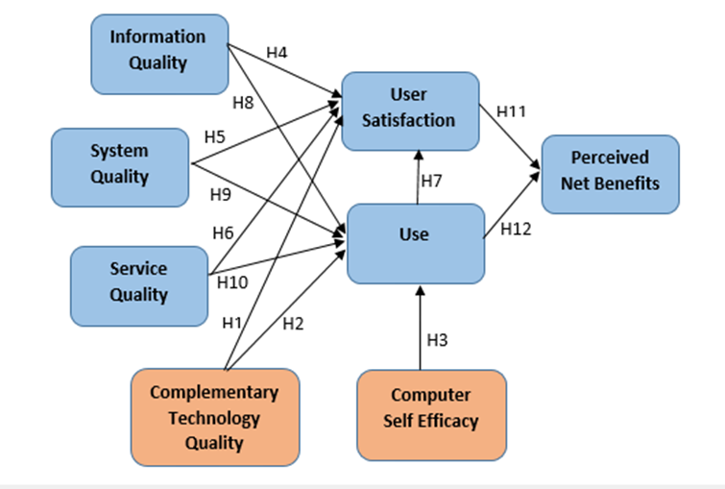
Figure 1. Modified Research Model

Hypothesis

When it comes to the hypothesized relationship between Courts’ E-commerce system success variable are based on the empirical study and report by DeLone and McLean (2003). They advise that the success model needs further improvement and support before it can be used as the basis for the choices of appropriate Information System Measurement. Consequently, the study hypothesized the following twelve hypotheses tested:

H1. Complementary technology quality will positively impact user satisfaction.
H2. Complementary technology quality will positively impact use.
H3. Computer Self Efficacy will positively impact use.
H4. Information quality will positively impact user satisfaction
H5. System quality will positively impact user satisfaction.
H6. Service quality will positively impact user satisfaction.
H7. Use will positively impact user satisfaction.
H8. Information quality will positively impact use.
H9. System quality will positively impact use.
H10. Service quality will positively impact use.
H11. User satisfaction will positively impact perceived net benefit.
H12.Use will positively impact perceived net benefit.

Construct Measurement

In order to ensure a valid and reliable conclusion of the E-commerce through a valid scale, the quantitative collection of data was done through the usage of past verified instrument. A reliable and valid instrument is Bailey and Pearson (1983) who has been tested and has become a commonly used instrument in the Information System field. For that reason the information quality was measured by a seven item scale just as Baily and Person (1983); however, it was modified to fit the specific context of the E-commerce system. When it comes to measure the E-commerce system quality a four item scale instrument of Ashibly (2011) was modified and used. In this research, it is considered service quality as a valid judgement of the system success as a result the measurement of service quality a five item scale by Chang et al. (2009) was modified and used. Furtherly, for the measurement of use, a four item scale was used based on researches by Balaban et al (2013) and Rai et al (2002). The User Satisfaction dimension was measured using Seddon and Yip (1992) four item scale. The E-commerce system perceived benefit it was measured by Alshibly (2011) and Tansely et al (2001) six item scale. The complementary technology quality aspect of the system Teece (1988) three item scale was modified and used. Lastly the computer self-efficacy was measured using Campeau and Higgins (1995) 10 scale item but was modified to fit the research context.

All the items were measured using a 7-point Linkert Scale from agree (7) to disagree (1). Table 1 shows the research construct and the survey items used to measure each dimension.

Table 1. The measurement items for questioners.
Construct | Survey questions | Source
Information Quality | IQ1: Courts’ E-commerce website provides you with information that is exactly what you need.  IQ2: Courts’ E-commerce provides you with information you need at the right time.  IQ3: Courts’ E-commerce website has sufficient information.  IQ4: Courts’ E-commerce website provides information that is relevant to your needs.  IQ5: Courts’ E-commerce website’s provides information that is relevant to your needs.  IQ6: Courts’ E-commerce website provides up-to-date information. | Bailey and Person (1983)
System Quality | SQ1: Courts’ E- Service website is easy to use.  SQ2: Courts’ E- service website is user-friendly.  SQ3: Courts’ E-commerce website provides information that is relevant to your job.  SQ4: Courts’ E-commerce website provides interactive features between users and system. | Alshibly, (2011)
Service Quality | SV1: Courts’ support staff keeps the company’s E-commerce website up to date.  SV2: When users have a problem with the E-commerce website, Courts’ support staff shows a sincere interest in solving it.  SV3: Courts’ E-commerce website support staff responds promptly when users have a problem with the E-commerce website.  SV4: Courts’ E-commerce website support staff tell users exactly when services will be performed. | Chang et al.,(2009)
User Satisfaction | US1: Most of the users bring a positive attitude or evaluation towards the E-commerce system.  US2: You think that the perceived utility about courts E-commerce system is high.  US3: Courts’ E-commerce has met your expectations.  US4: You are satisfied with Courts E-commerce website. | Seddon and Yip (1992)
Use | U1: You use Courts E-commerce system frequently.  U2: You depend upon Courts’ E-commerce system.  U3: You are able to complete a task using Courts’ E-commerce even if there was no one around to tell you what to do.  U4: You have the knowledge necessary to use Courts’ E-commerce. | Balaban et al., (2013)  Rai et al., (2002).
Perceived Net Benefits | NB1: Courts’ E-commerce aids in improving my efficiency of transactions.  NB2: Courts’ E-commerce aids me in saving money.  NB3: Courts’ E-commerce aids me in getting items at better prices.  NB4: Using the company’s E-commerce s identifies to me the new products and what is on stock.  NB5: Using the company’s E-commerce allows my family to purchase from anywhere and I can get it in Belize with no challenge.  NB6: Courts’ E-commerce cuts my overall expenses. | Alshibly, (2011); Tansley et al, (2001)
Complementary Technology Quality | CTQ1: The software on the device (desktop computer, laptop, mobile device) I use to access Courts’ E-commerce is adequate. CTQ2: The device hardware (desktop computer, laptop, mobile device) I use to access Courts’ E-commerce is adequate. CTQ3: The device (desktop computer, laptop, mobile device) I use to access Courts’ E-commerce has an adequate internet connection in regards to speed and reliability. | Teece, D. J. (1988).
Computer Self-Efficacy Measure | CSM1: I can use the Courts’ E-commerce if there was no one around to tell me exactly what to do. CSM2: I can use Courts’ E-commerce even though I had never used an information system like it before. CSM3: I can use Courts’ E-commerce only if I had the manual for reference. CSM4: I can use the Courts’ E-commerce if I had seen someone else using it before trying it myself. CSM5: I can call someone for help if I got stuck using Courts’ E-commerce. CSM6: I can use Court’s E-commerce if someone else helps me get started. CSM7: I can use Courts’ E-commerce if I had a lot of time to complete the job for which the E-commerce was provided. CSM8: I can use the built-in help facility for assistance when using/navigating the E-commerce. CSM9: I can use the E-commerce if someone showed me how to do it first. CSM10: I had previously used a similar E-commerce to do the same job. | Compeau, D. R., & Higgins, C. A. (1995).

Data Analysis and Discussion

The purpose and objective of this research was to evaluate the effectiveness and efficiency of the E-commerce system at a private sector company, Courts Belize Ltd., which based on the survey results, conclusion was to be made if the E-commerce users find the system as effective as how it was expected to be. The 60 random customers of Courts Belize Ltd. used as the sample size for the research gave back their responses, resulting in a 100% response rate. Apart from the questionnaires used to collect primary data, secondary data was also used. The following represents the results of the primary data collected throughout the 60 questionnaires given out.
Table 2 represents the characteristics of the 60 respondents.

Table 2. Characteristics of the respondents ( N=60)
Characteristics | Number | Percentage
Age
18-25 | 16 | 26.67%
26-30 | 16 | 26.67%
31-50 | 22 | 36.67%
>50 years | 6 | 10%
Years as a customer
<2 years | 17 | 28.33%
2-4 | 18 | 30%
5-10 | 15 | 25%
> 10 years | 10 | 16.67%
Gender
Male | 27 | 45%
Female | 33 | 55%
Education Level
PhD | 1 | 1.67%
Master | 1 | 1.67%
Bachelors | 12 | 20%
Associates Degree | 27 | 45%
High School | 15 | 25%
Primary School | 4 | 6.67%

The histograms below show the results of the data gathered through the questionnaire from Courts Belize Ltd. customers to determine the E-commerce system success. As mentioned under the construct measurement the questions were based under the dimension Information Quality, System Quality, Service Quality, User Satisfaction, Use, Perceived Net Benefit, Complementary Technology Quality, and Computer Self-Efficacy Measure

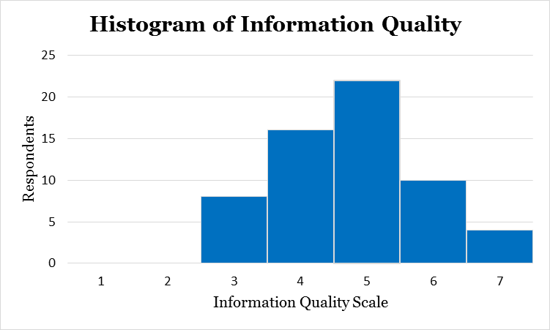
Figure 2: Information Quality

Figure 2: The Information Quality histogram shows that most customers believe that Courts’ E-commerce System information has a satisfactory quality. Most customers believe the E-commerce website provides with information that is exactly what is needed, that is needed at the right time, that is sufficient, that is relevant to the needs, that is easy to understand and that is up to date at a satisfactory level.

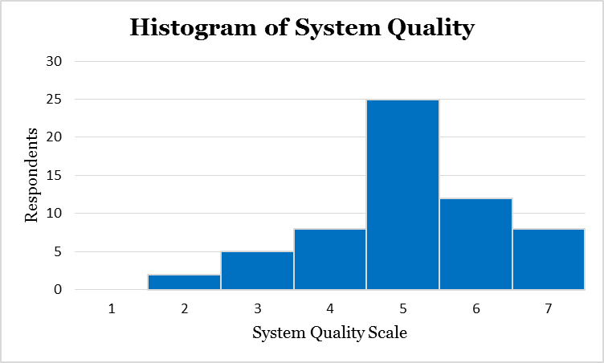
Figure 3: Information System Quality

.
Figure 3: The Information System Quality histogram shows that most customers believe that Courts’ E-commerce System quality is satisfactory. Most customers agree that the E-commerce system is easy to use, is user-friendly, provides with high-speed information access and provides with interactive features between users and the system in a satisfactory quality.

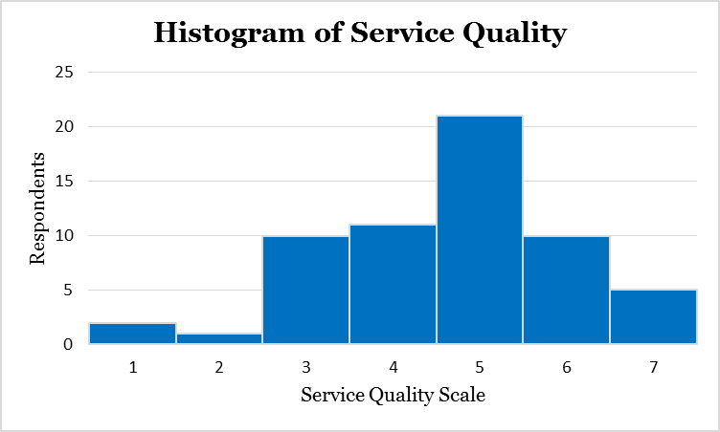
Figure 4: Service Quality

Figure 4: Service Quality histogram shows that most customers believe that Courts’ E-commerce system service quality is satisfactory. Most agree that that E-commerce website is kept up to date by support staff, that support staff shows a sincere interest in solving problem for users, that support staff respond promptly when users have a problem and that the system tells exactly when services will be performed are at a satisfactory level. There are a few who believe the service quality is poor.

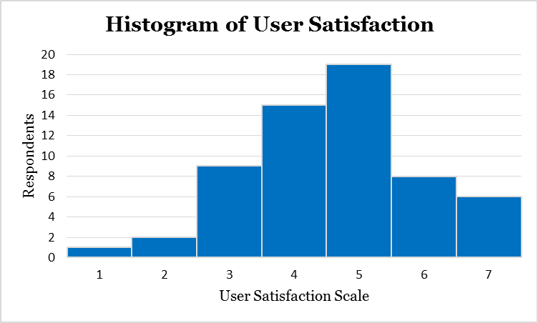
Figure 5: User Satisfaction

Figure 5: The user satisfaction histogram shows that most customers believe that Courts’ E-commerce has a satisfactory level of user satisfaction. Most customers’ agree that their positive attitude towards the E-commerce system, their perception of the system being useful, that the system has met their satisfaction and that they are satisfied with the system are at a satisfactory level. There are a few that disagree with this.

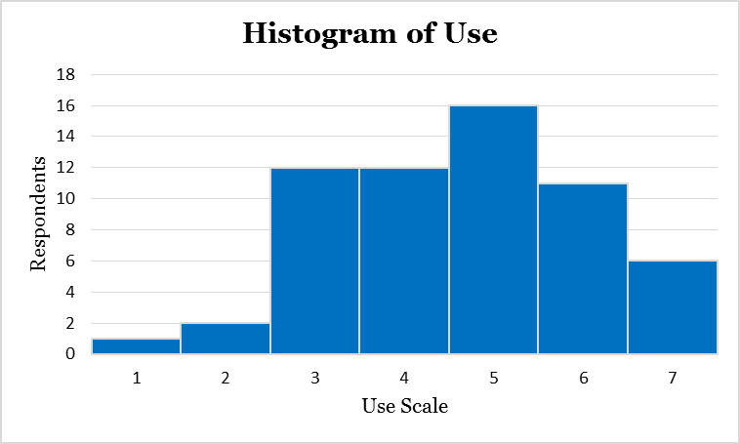
Figure 6: Use

Figure 6: The use histogram shows that most customers believe that the use of the e-commerce system is at a satisfactory level. Most customers agree that they frequently use the system, their dependency on the system, their capacity of using the system and their knowledge to use the system is at a satisfactory level. However, there is a high number of customers who don’t agree as they perceive its use to be poor.

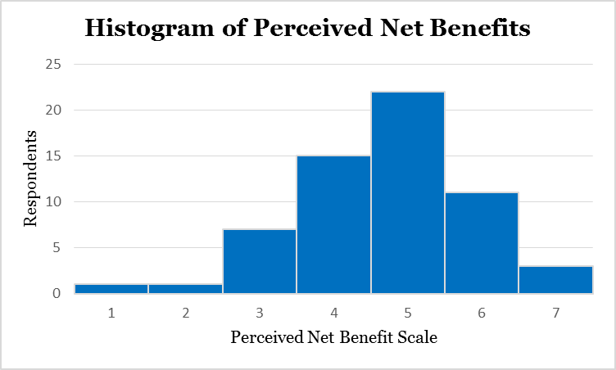
Figure 7: Perceived Net Benefit

Figure 7: The perceived net benefit histogram shows that the perceived benefit of the e-commerce is slightly balance, as only little more than half of the respondents agree with the perceived net benefit such as efficiency transaction, saving money, getting items at a better price, know about new items and the ones available in stock, no challenge to purchase online from anywhere and save time. On the other hand a little less than half aren’t satisfied and don’t agree much to the perceived net benefits.

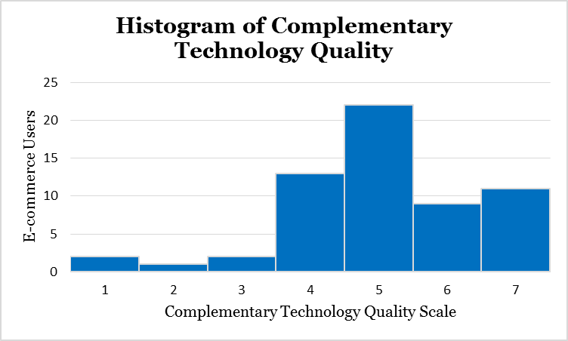
Figure 8: Complementary Technology Quality

Figure 8: The Complementary technology Quality Histograms shows that most customers believe that the complementary technology used for using the E-commerce system is satisfactory. Most customers agree that the complementary technology used such as software and device hardware are adequate satisfactory and that the internet connection used is satisfactory. A few customers disagree.

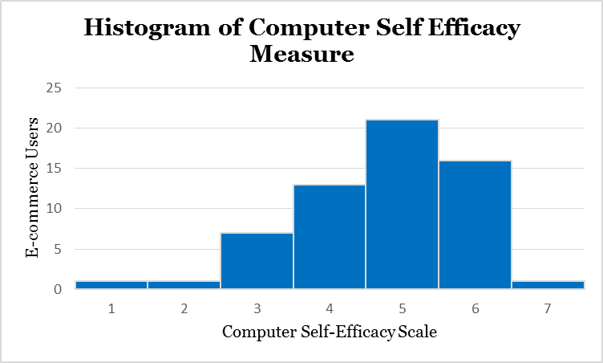
Figure 9: Computer Self-Efficacy

Figure 9: The computer self-efficacy histogram shows that most customers believe they are at average when it comes to measuring them on being able to use computer for the E-commerce system; however a minimum amount is shown not be too knowledgeable of how to use computer.

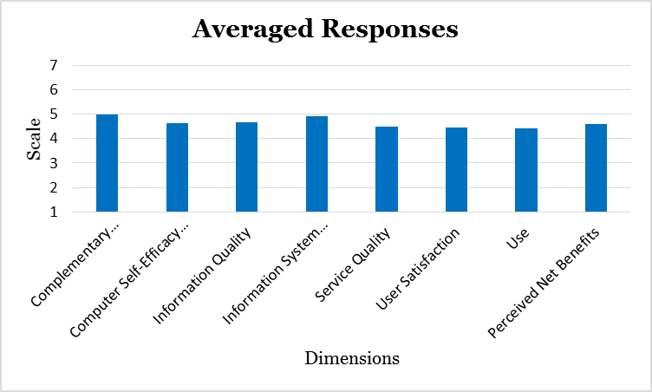
Figure 10: Average Response

Figure 10: The Average response histogram shows the overall average response of each dimension of model used to measure the information system success. The histograms portrays that computer self-efficacy, information quality, service quality, user satisfaction and use are the dimensions that cause for the customers not to be able to get the maximum benefits of the e-commerce system.

Discussion
The solely purpose of researching on the Courts Belize Limited E-commerce system is to be able to determine if whether the system is effectively helping the firm to achieve its goals and objectives as it is expected to do. Due to the purpose, the most effective way of measuring it was through the usage of the DeLone and Mclean (2003) Information System Success Model as the base for the study. This led to use the six dimension model which involved information quality, system quality, service quality, user satisfaction, use, and perceived net benefit as the key dimension to measure the E-commerce system success. However, in order for the research to fit with the context of the study which is a developing countries, two dimensions were added which are complementary technology, and computer self-efficacy. The additional two dimensions were added as they are two major elements lacked at developing countries. The computer self-efficacy was used to measure if customers have the skills and knowledge to use the E-commerce system and the complementary technology was used to measure the quality of resources such as software, hardware and internet to use the E-commerce system.
The results of the information quality states that must customers approximately 36 agree that the information quality is averagely and above, satisfactory. Due to this it can be said that the information quality of the e-commerce system is up to average in its effectiveness to make the system successful. On the other hand approximately 16 can be said to be a neutral response as if they aren’t really sure if the information quality is at a satisfactory quality or in a poor quality. This can be the result that they prefer not to take a stand if whether the information is at a good quality. Lastly for the information quality 8 gave a scale that can be said the information quality is poor which can be the result of their level of education or any other factors which cause them to find the information in a poor state.
Further on, the results of the system quality shows that must customers a total of 45 agree that the system quality is at average and above in its quality. However approximately 8 are neutral and aren’t really sure if the system quality is satisfactory or poor in quality. This might be maybe because at times the system works satisactory but at times its quality is poor or even it might be because customers have had both experience and so aren’t sure if they can say it is satisfactory or not. Lastly only 2 believe the system quality is poor and it might be that they evaluate it based on the last time they used the system which might have been a long time or don’t use the system.
On the other hand the results of the service quality shows that approximately a total of 36 respondents agree that the service quality is up to average and above, in satisfactory. This shows that the service quality is at a success level. However, 11 respondents took a neutral stand which might be the result that they have experience a poor and a satisfactory service quality so they took a neutral stand. This can also be the result of that the respondents have never used the e-commerce service and that is why they couldn’t put if it is satisfactory or not. Two respondents responded that the service quality is completely poor which migt have been that they had only used the system once and they had a very bad expereince. The other 11 respondents also ranked the service quality low. This might have resulted because maybe they are customers who are old customers who use to the system long ago and not recently and they are answering it based when e-commerce system was just implemented.
Additonally, the results for user satisfaction shows that 33 respondents are averagely and above satified with the e-commerce system. This might have been the result that these customers have good hardware and good internet connection, understand the information on the E-commerce website, see the system quality satifactory, have had good service quality experience or use the system frequently. Fiifteen of the respondents took a neutral stand and this might have been does who barely use the system, or who have never used the system or maybe those who have a long time they don’t use the system. Eleven respondent are poorly satisified which could have been the result of their complementary technology is not at a good standard, or those who don’t understand the information on the system and not even the system which makes them poorly satisfied. Only one respondendent is completley unsatisfied which may have been the result that has never used the E-commerce system or has had a very bad service quality experience or doesn’t has the needed technology, or information isn’t completely understood or the system quality is simply poor or a little of each.
When it coms to the use dimension the result show that 33 respondents use the system averagely and above. This could have been the result of having good complementary technology, have good computer self efficacy, understand the information on the E-commerce website well, see the system at a good quality or have had good service quality experience. Twelve respondents were neutral, which might have been that they have had good and bad experience with their complementary technology, their computer self-efficacy, the information quality, system quality, and service quality. Fourteen respondents responded that they barely use the E-commerce system. This might have been due to the limited acces of good complementary technology, limited skills to use computer, limited information provided, poor system quality, or because of the poor service quality. Only one respondent seems that doesn’t uses the system or simply doesn’t has the necessary technogy and skills to use the system, or completley doesn’t understand the information, or sees the system quality poor, or has had a very bad service quality experience or a little of each.
The perceived net benefits results show that 36 respondents perceive that the net benefit they get from the E-commerce system is on average and above, satisfactory. This shows that most customers agree they receive an average level of benefits maybe because they are highly satisfied of maybe because they are common users of the system. Fifteen respondents took a neutral stand which might have been the result that they are sometimes satisfied and sometimes they are not or because they use the systems not frequently but not rarelt neither. Eight respondents think the benefit they get of the system is littl and might be because they are minimaly satisfied or they barely use the system or both. Only one respondent thinks the benefit of the system is almost nothing and might be the result that the customer is complelety unsatisfied or doesn’t use the system.
On another point the results of complementary technology quality shows that 42 which is the majority of respondent agree the quality of the complementry technology to use the E-commerce system is on average and above. This could have been the result of many factors which weren’t covered in the research such as place they live like urban areas, their income etc. Thirteen of the respondents responded neutral which might have been that at times the complementary technology works good and at time it doesn’t. Three respondents responded that their complementary technology quality is poor. This might have been the result of the area they live, lack of income to pay for a higher quality etc. Only 2 respondents agree that its technology quality is very poor maybe because of the lack of access or lack of finance to pay etc.
The results of computer-self efficacy shows that most customers in total 38 agree that they are at average and above in computer self efficacy, meaning that most of them know how to use computer. Thirteen customers were neutral in their response as they might only know certain aspects of computers but not all. Eight respondents think their level of computer self efficacy is low and might be due to the lack of experience or even high education. Only one respondent agrees its computer self effficay is low and might be due to reason that has never used a system before.
Lastly when it comes to the averaged responses of the dimension it shows that use received the lowest average response, which highlights that the system isn’t being used as much.This low usage of the system puts a high costrain on the perceived net benefit level. There is the need to increase the usage of the system which can be achieved according to the results by increasing the information quality, system quality and service quality. User satisfaction received the second low average response, showing that customers aren’t highly satisifed with the system. This means that most customers don’t have a positive attitude towards the system, that the system isn’t seen as much useful and that it hasn’t met customer expectations at full and cusomers aren’t highly satisfied. By the user satisfaction being low this highly impacts the perceived net benefit of the system. The user satisfaction needs to be improved by improving information quality, system quality, service quality and by increasing use and also by training on how to use the system.
Service quality received the third lowest average response. This means that the E-commerce website lacks up to date information, and although there is a maintenance team there is not a high degree of interest by the support staff to keep the system at a higher quality and there is little interest by support staff to respond users when they have challenges with the E-commerce system. Additonally, when the maintainance team willl update the system or the system will be down customers aren’t made aware which leads to unsatisfied customers.
Th other dimensions such as perceived net benefit, computer self efficacy and information quality receive almost the similar average response being the fourth lowest. This means that customers level of efficient transaction, save money save, get better prices, know about in stock items and save time benfits isn’t very high. For computer self efficacy being after the level of the perceived benefit in response average supports that in developing country there isn’t much computer self efficient. This supports the idea that this is lacked at the developing countries which affect the use and when use is affected it affects the net benefit. The information quality is also low which affects the user satisfaction and the use of the system.
Lastly the highest dimension is complemenatry technology which doesn’t supports the notion that complementary technology is lacked at developing countries. The second highest dimension is system quality which is averaged higher than all other dimensions which is surprising as if the system quality is high then it would be expected to cause a high average in dimensions like user satisfaction and use but this isn’t the results in the study which could have been for factors the study didn’t covered.
In total what can be said is that the E-commerce system success is on average. The major cause of this is the low usage of the system and the low user satisfaction. Also research of the E-commerce system based on DeLone and Mclean (2003) is stated that service quality in e-commerce highly determines the system success. From what has been seen on the results that use, user satisfaction and service quality is lower than all which supports that they play a major role in the net benefit of the system which creates for Courts Belize Ltd. E-commerce system not to be more than averagely successful.

Conclusion
The purpose of going through the whole process of research was to evaluate the success of E-commerce system of a private company, Courts Belize Ltd. in a developing country, Belize. Based on the results of the research, it can be concluded that the E-commerce of the private firm is classified as averagely successful as all results that were 4.5 and above were round off to 5. Due to rounding off the results the overall rating of the E-commerce system were a little above average; however, the E-commerce needs improvement to be at a higher average on its success. The results show that the lowest ranking constructs were use, user satisfaction, and service quality. As a result if there isn’t much use of the E-commerce system, user aren’t highly satisfied then it influences the perceived net benefit to be at a low rate since both are independent variables of perceived net benefit. However, based on the results mostly being on average then it can be decided that the system is slightly successful. Therefore it can be said that the system is slightly assisting the company in achieving its goals and objectives. This supports that the DeLone and McLean (2003) IS Success Model and the two additional constructs are effective in evaluating the success of an information system as in this research the E-commerce deficiency were identified and where improvements needs to be made in order to increase the success of the information system above average and make it more effective and efficient.

Recommendations

Although the E-commerce is classified as successful it shouldn’t be ignore that it was slightly successful. With this in mind the firm should take the necessary steps to increase its system efficiency. The improvement should be focus in use and user satisfaction. To improve use the company should try teach customers how to use the system through various means such as video tutorial, improve its information quality by having up to date information and easy to understand and should improve service quality by ensuring that the support staff works along with customers. To improve user satisfaction the firm should focus on improving its information on the E-commerce website, its service quality by working hand in hand with customers, and by increasing the usage of the system. Additionally, the firm should try maintain and keep up to date the information system. By achieving the improvement of use and user satisfaction the firm will be able to increase customers perceived net benefit which will result in a high success level of the E-commerce system.

However, due to the study limitation we recommend that for further research on the topic researchers collect more empirical evidence from a larger sample size and from various private businesses so that the success on E-commerce system in the whole country, Belize, can be accurately determined. On the other hand for a research of the success of the E-commerce in Courts Belize, it is recommended that they take a sample size from all districts and to cover gaps such as ensuring respondents are users of the system or have recently used it. This will lead to a more accurate conclusion.

Limitations

When carrying out the research study to determine the E-commerce system success the main limitation encountered was the lack of time. This caused for a limited amount of questionnaires to be distributed and for it to be distribute in a one location as the time expand for the research is one semester and resources were limited. Otherwise a more extensive research would had been able to take place using a larger sample size from all the districts or at least where the Courts Belize Ltd. has a branch. Time caused for the limitation of sample size to be only 60 causing for a low accurate result.
Another limitation was to control if whether respondents had truly used the E-commerce system. Also a limitation was the time of respondents who a few of them seemed not to have much time to answer the questionnaire and responded them without properly reading each question. This could have greatly affected the research results.

References

Al-Shibly, H. (2011). Human resources information systems success assessment: An integrative model. Australian Journal of Basic and Applied Sciences, 5(5), 157-169.

Alyoubi, A. A. (2015). E-commerce in Developing Countries and How to Develop Them During the Introduction of Modern Systems. Procedia Computer Science, 65, 479 – 483.

Alshibly, H. H. (2014). Evaluating E-HRM success: A Validation of the Information Systems Success Model. International Journal of Human Resource Studies, 4(3), 107. doi:10.5296/ijhrs.v4i3.5929

Avgerou, C., (2008). Information systems in developing countries: a critical research review. Journal of Information Technology, pp 133-146.

Bailey, J. E.; Pearson, S. W., (1983). Development of a Tool for Measuring and Analyzing Computer User Satisfaction. Management Science, 29, (5), 530-545.

Balaban, I., Mu, E., & Divjak, B. (2013). Development of an electronic Portfolio system success model: An information systems approach. Computers & Education, 60 (1), 396-411.

Ballantine, J., Bonner, M., Levy, M., Martin, A., Munro, I., & Powell, P. L. (1996). The 3-D model of information systems success: the search for the dependent variable continues. Information Resources Management Journal (IRMJ), 9 (4), 5-15.

Chang, H. H., Wang, Y. H., & Yang, W. Y. (2009). The impact of e-service quality, customer satisfaction and loyalty on e-marketing: Moderating effect of perceived value. Total Quality Management, 20 (4), 423-443.

Chatterjee, D., Grewal, R., & Sambamurthy, V. (2002). Shaping up for e-commerce: Institutional enablers of the organizational assimilation of web technologies. MIS Quarterly, 26(2), 65–89.

Compeau, D. R., & Higgins, C. A. (1995). Computer self-efficacy: Development of a measure and initial test. MIS Quarterly, 19, 189-211.

DeLone, W. H., & McLean, E. R. (1992). Information systems success: the quest for the dependent variable. Information systems research, 3(1), 60-95.

DeLone, W. H., & McLean, E. R. (2003). The DeLone and McLean Model of Information Systems Success: A Ten-Year Update. Journal of Management Information Systems, 19 (4), 9-30.

Garrity, E. J., & Sanders, G. L. (Eds.). (1998). Information systems success measurement. Igi Global.

Ghobakhloo, M., and Tang, H. (2015). Information system success among manufacturing SMEs: case of developing countries. Information Technology for Development, Vol. 21, No. 4, 573–600.

Hawk, S. (2004). A Comparison of B2C E-Commerce in Developing Countries. Electronic Commerce Research, 4: 181–199.

Heeks, R. (2001). Information Systems and Developing Countries: Failure, Success, and Local Improvisations. The Information Society, 18:101–112.

Heeks, R. (2002). Failure, Success and Improvisation of Information Systems Projects in Developing Countries. Development Informatics, (11), 1-17. Retrieved February 05, 2017.

Krishna, S., and Walsham, G. (2005). Implementing Public Information Systems in Developing Countries: Learning from a Success Story. Information Technology for Development, Vol. 11 (2), 123–140.
Li, D., Huang, W., Luftman, J., & Sha, W. (2010). Key Issues in Information Systems Management: An empirical Investigation from a developing country’s Perspective. Journal of Global Information Management, 18(4), 19-35.

Molla, A., & Licker, P. S. (2005). Perceived E-Readiness Factors in E-Commerce Adoption: An Empirical Investigation in a Developing Country. International Journal of Electronic Commerce, Vol. 10, No. 1, pp. 83–110.

Petter, S., DeLone, W., & McLean, E. (2008). Measuring information systems success: models, dimensions, measures, and interrelationships. European Journal of Information Systems, 17(3), 236-263.

Rai, A., Lang, S. S., & Welker, R. B. (2002). Assessing the validity of IS success models: An empirical test and theoretical analysis. Information systems research, 13(1), 50-69.

Seddon, P. B. (1997). A respecification and extension of the DeLone and McLean model of IS success. Information systems research, 8(3), 240-253.

Seddon, P. and Yip, S. K. (1992), "An Empirical Evaluation of User Information Satisfaction (UIS) Measures for Use with General Ledger Account Software," Journal of Information Systems, 6(spring), 75-92.

Solaymani, S., Sohaili, K., & Yazdinejad, E. A. (2012). Adoption and use of e-commerce in SMEs. Electronic Commerce Research, 12(3), 249–263.

Tan, J., Tyler, K., & Manica, A. (2007). Business-to-business adoption of ecommerce in China. Information& Management, 44(3), 332–351.

Tansley, C., Newell, S., & Williams, H. (2001). Effecting HRM-style practices through an integrated human resource information system: An e-greenfield site. Personnel Review, 30 (3), 351-371.

Travica, B. (2002). Diffusion of Electronic Commerce in Developing Countries: The Case of Costa Rica. Journal of Global Information Technology Management.

Walsham, G., Robey, D., and Sahay, S. (2007). Foreword: Special Issue on Information Systems in Developing Countries. MIS Quarterly, Vol. 31, No. 2, pp 317-326.

Walsham, G., & Sahay, S. (2006). Research on Information Systems in Developing Countries: Current Landscape and Future Prospects. Information Technology for Development, Vol. 12 (1), 7–24

William H. DeLone and Ephraim R. McLean (2016), "Information Systems Success Measurement", Foundations and Trends® in Information Systems: Vol. 2: No. 1, pp 1-116.

World Trade Organization., (2013).E-commerce in developing countries Opportunities and challenges for small and medium-sized enterprises. Pdf.

Zwass, V. (1996) Electronic Commerce: Structure and Issues. International Journal of Electronic Commerce, 3-23.

Questionnaire (Courts Belize E-commerce Website Evaluation)
Purpose
This questionnaire asks for information about your experience concerning the use of Courts E-commerce website. We will use the information gathered to evaluate the E-commerce performance and we will make recommendations on how the E-commerce website can be improved so that you can receive maximum benefits when using Courts E-commerce Website.
Instructions
Please understand that your individual responses will be strictly confidential and all information will be presented in an aggregate form. Participation is voluntary. The results will be used to improve customer’s E-commerce satisfaction and to find possible improvements. When responding please answer honestly and thoroughly. Thank you for your time.
Sincerely,
University of Belize MIS Research Team
Background Information | Answers:
Please indicate your age range: | 18-25 26-30 31-50 >50
Please indicate the number of years you have been a customer of Courts Belize. | < 2 2- 4 5- 10 >10
Please indicate your gender: | Male Female
Please indicate highest education level attained: | PhD Masters Bachelors  Associates High School Primary School

Indicate your agreement with each statement by rating it from (1) strongly disagree to (7) strongly agree.
Information Quality | Disagree -------------------------------Agree
Courts E-commerce website provides you with information that is exactly what you need. | 1 2 3 4 5 6 7
Courts E-commerce provides you with information you need at the right time. | 1 2 3 4 5 6 7
Courts E-commerce website has sufficient information. | 1 2 3 4 5 6 7
Courts E-commerce website provides information that is relevant to your needs. | 1 2 3 4 5 6 7
Courts E-commerce website’s provides information that is easy to understand. | 1 2 3 4 5 6 7
Courts E-commerce website provides up-to-date information. | 1 2 3 4 5 6 7
Information System Quality | Disagree -------------------------------Agree
Courts E-commerce website is easy to use. | 1 2 3 4 5 6 7
Courts E-commerce website is user-friendly. | 1 2 3 4 5 6 7
Courts E-commerce website provides high-speed information access. | 1 2 3 4 5 6 7
Courts E-commerce website provides interactive features between users and the system. | 1 2 3 4 5 6 7
Service Quality | Disagree -------------------------------Agree
Courts support staff keeps the company’s E-commerce website up to date. | 1 2 3 4 5 6 7
When users have a problem with the E-commerce website, Courts support staff shows a sincere interest in solving it. | 1 2 3 4 5 6 7
Courts E-commerce website support staff responds promptly when users have a problem with the E-commerce website. | 1 2 3 4 5 6 7
Courts E-commerce website support staff tell users exactly when services will be performed. | 1 2 3 4 5 6 7

User Satisfaction | Disagree -------------------------------Agree
Most of the users bring a positive attitude or evaluation towards Courts E-commerce system. (You have a positive attitude towards) | 1 2 3 4 5 6 7
You think that the perceived usefulness about Courts E-commerce system is high. | 1 2 3 4 5 6 7
Courts E-commerce has met your expectations. | 1 2 3 4 5 6 7
You are satisfied with Courts E-commerce website. | 1 2 3 4 5 6 7
Use | Disagree -----------------------------Agree
You use Courts E-commerce system frequently. | 1 2 3 4 5 6 7
You depend upon Courts E-commerce system. | 1 2 3 4 5 6 7
You are able to complete a task using Courts E-commerce even when there is no one around to guide you on what to do. | 1 2 3 4 5 6 7
You have the knowledge necessary to use Courts E-commerce. | 1 2 3 4 5 6 7
Perceived Benefits | Disagree -----------------------------Agree
Courts E-commerce aids in improving my efficiency of transactions. | 1 2 3 4 5 6 7
Courts E-commerce aids me in saving money. | 1 2 3 4 5 6 7
Courts E-commerce aids me in getting items at better prices. | 1 2 3 4 5 6 7
Using the company’s E-commerce s identifies to me the new products and what is on stock. | 1 2 3 4 5 6 7
Using the company’s E-commerce allows my family to purchase from anywhere and I can get it in Belize with no challenge. | 1 2 3 4 5 6 7
Courts E-commerce aids me in saving time. | 1 2 3 4 5 6 7
Complementary Technology Quality | Disagree -----------------------------Agree
The software on the device (desktop computer, laptop, mobile device) I use to access Courts E-commerce is adequate. | 1 2 3 4 5 6 7
The device hardware (desktop computer, laptop, mobile device) I use to access Courts E-commerce is adequate. | 1 2 3 4 5 6 7
The device (desktop computer, laptop, mobile device) I use to access Courts E-commerce has an adequate internet connection in regards to speed and reliability. | 1 2 3 4 5 6 7

Computer Self-Efficacy Measure | Disagree -----------------------------Agree
I can use Courts E-commerce if there was no one around to tell me exactly what to do. | 1 2 3 4 5 6 7
I can use the Courts E-commerce even though I had never used an information system like it before. | 1 2 3 4 5 6 7
I can use Courts E-commerce only if I had the manual for reference. | 1 2 3 4 5 6 7
I can use Courts E-commerce if I had seen someone else using it before trying it myself. | 1 2 3 4 5 6 7
I can call someone for help if I got stuck using Courts E-commerce. | 1 2 3 4 5 6 7
I can use the Courts E-commerce if someone else helps me get started. | 1 2 3 4 5 6 7
I can use Courts E-commerce if I had a lot of time to complete the job for which the E-commerce was provided. | 1 2 3 4 5 6 7
I can use the built-in help facility for assistance when using the E-commerce website. | 1 2 3 4 5 6 7
I can use Courts E-commerce if someone showed me how to do it first. | 1 2 3 4 5 6 7
I can use Courts E-commerce if I had previously used a similar E-commerce to do a similar task. | 1 2 3 4 5 6 7

Please return this survey to the person who gave you the form.
Thank you for your participation.

