Evaluating MOODLE Success:
University of Belize Learning Management System
Research Paper
Alfonso Perera  University of Belize  College Street, West Landivar  Belize City, Belize  alfonsoperera3a@gmail.com | Amira Correa  University of Belize  College Street, West Landivar  Belize City, Belize  amielencorrea@gmail.com
Monica Flowers  University of Belize  College Street, West Landivar  Belize City, Belize  2015111888@ubstudents.edu.bz | Isabelle Tun  University of Belize  College Street, West Landivar  Belize City, Belize  2015112016@ubstudents.edu.bz

Abstract
Though there already exists countless research related to the success of information system models, there are not so many that focus specifically on the approaches and measurements of evaluating the success of such systems within educational institutions. This research adapted Delone and Mclean’s Information System success model which features various factors with respect to information quality, system quality, service quality, quality of all complementary assets, the user satisfaction, use and perceived net benefits. In addition, two constructs were included such as: Complementary Technology Quality and Computer Self Efficacy, since these will assist us to better determining the success of an information system used in a third world country.
Keywords: Moodle; information systems success model; perceived net benefit.
Introduction
Many organizations have invested heavily on information and communication technology to uphold different business functions. To become increasingly effective and viable, these organizations are finding new and improved ways of operating (Kanaracus, 2008). For this reason, they must ensure that they have a proper management information system in place geared toward their continued success.
As the name implies, a Management Information System is a system of compiled information that provides management with the necessary tools to organize, and manage different business processes. Helping in making any organization more technologically inclined, these systems specifically studies people, technology and organizations and the relationship among them (Mays Business School, 2010).
Management Information Systems varies across industries as they are designed to fit the unique nature of every business environment. When it comes to universities, learning management information systems are used primarily to enhance teaching and learning experience of the teacher and most importantly, the students. As it relates to the management information system used at the University of Belize, known as Moodle, a learning management system (LMS) is a system used by educational institutions and designed to facilitate the learning process by making the academic life of students more accessible, student friendly and interactive with respect to information quality, system quality, service quality, quality of all complementary assets, the user satisfaction, use, complementary technology quality, computer self-efficacy and perceived net benefits of the system, as these factors together, all play a crucial role in the success of Moodle or any information system for that matter.
Moodle is an E-learning tool used by the university to make information readily available to students in a timely manner, to increase overall accessibility, to increase the effectiveness of delivering course content, to promote interactivity among students and teachers and to allow self-pacing for students (Bhuasiri et al., 2012). It provides them the opportunity to become more integrated in a flexible, accessible and diverse learning atmosphere geared to improve the needs of students (Bhrommalee, 2012).
One of the primary objective of any educational institution is to serve its customers who are its students. More specifically, the objective of an educational institution in a developing country such as Belize, is to become more familiarized with the different benefits that information systems have to offer all stakeholders involved. One of these benefits include widening the school’s customer base, i.e. attracting more students to generate more revenue per person and grow the institution to one of international accredited standards. Being that learning management systems and the concept of e-learning are becoming quite popular in developed countries, developing countries must begin to shift its focus from the traditional approaches to education and begin to adapt to the changes in technology. For this reason, it is important that we attempt to measure the benefits and effects of these information systems on the said university.
The end results of this research will be of paramount importance to the success of the information system moving forward. This research will allow us to ascertain the amount of users satisfied with the system and the amount not satisfied (Sebastian D, Sebastian W. & Torsten E. 2013). Being that the paper focuses on the different success factors, specific reasons can be obtained as to why or why it is not a success. With that information, management can then try to adjust the shortcomings of those factors in order to make it more effective and reflective of the students’ needs.
In conclusion, the positive effects that a learning management system has on the University of Belize and whether it is effective and serving its purpose is the primary goal of this research. The much needed benefits that having a learning management system can have is of great importance to the efficiency and advancement of the university, as it would allow the university to serve its students more effectively while being up to date on the advancements brought by the 21st century technological era.
Theoretical Foundation: Information Systems Success
A Learning Managing System is an Information System used to improve the learning experience for students and for lecturers to efficiently manage their courses. At the University of Belize, the Learning Management System used to facilitate a collaborative educational experience is Moodle. However, is this learning management system achieving its purpose? We will proceed in describing the theoretical framework of Delone and Mclean (1992) that will be used to assist in determining the success of this Learning Management System.
Delone and Mclean’s Success Model was developed in 1992 to assist MIS researchers in a model that can be used in their research. The study focused to organize the extensive research, create a comprehensive taxonomy and of course identifying the dependent variables that determine Information System Success. Delone and Mclean’s emphasized the importance of these dependent variables since these were the variables that would ultimately measure the effectiveness of an Information System.
For Delone and Mclean’s research in 1992 an estimated 180 articles dated from 1949, were used to develop the descriptive model. The taxonomy hypothesizes six major constructs to measure Information System Success, they are: System Quality, Information Quality, Use, User Satisfaction, Individual Impact and Organizational Impact.
Delone and Mclean (1992) built on Shannon and Weaver’s (1949) work which defined the technical level, the semantic level and the effectiveness level. The technical level was defined as the accuracy and efficiency of a system, the semantic level is described as the success of information in conveying the intended meaning and the effectiveness level is the effect of the information on the receiver. They also built on Mason’s (1978) research which re-labeled Shannon and Weaver’s “effectiveness” level to “influence.” Mason’s research also defined it as the hierarchy of events which take place at the receiving end by defining the influence level of information. These two research were then used as a foundation to develop the six constructs to measure information system success. Overall the model described these constructs to be both interrelated and interdependent, unlike many research that would measure variables independently and fail to identify how they influence each other.
Since the publication of the research to the summer of 2002, there were 285 articles that made reference to the Delone and Mclean’s Information System Success Model (Delone & Mclean, 2003). Hence, this Information System Success Model has implemented some structure in the methods used to measure MIS success. As shared by Delone and Mclean (2003), several of the researchers “used the model to support their chosen success variable rather than to inform the development of a more comprehensive success construct.” Hence, they disregarded the author’s conclusion that the Information System Success model is an interdependent and interrelated construct.
The Delone and Mclean Success Model was not tested empirically, however there were several research that validated the model. To be specific, two research primary focused on testing and validating Delone and Mclean’s Information System Success Model. Namely, Seddon and Kiew (1994) and Rai et.al (2002). In the study conducted by Seddon and Kiew, 104 users were surveyed and a relationship was identified between “system quality”, “user satisfaction and “individual impact.” In addition, a relationship was found between “user satisfaction” and individual impact.” In the test conducted by Rai et al., 274 users of a university were surveyed for a “goodness-of-fit test” and some of the goodness-of-fit indicators were Significant. Overall from the several studies reviewed, the results strongly support the interrelationship and interdependence among the different constructs of the Information System Success Model.
There have also been several research papers that have critiqued, extended or challenged the model, such as the research done by Seddone (1997). Seddone argues that the inclusion of both variance and process interpretation in the model can lead to confusion. Seddone also argues for the removal of the success construct: “system use.” Since he believes the model is a process model and not a casual mode. Researchers have also described the application challenge of the Success Model. Delone and Mclean explained that since the model was the first of its kind, this was expected, for which reason they indicated the model needs further development and validation before it can be selected as a model to measure Information system Success.
Based on the different finding made in 2003, Delone and Mclean decided to update the 1992 Information System Success Model. This was done in order to make the model more useful and to incorporate e-commerce, which is an important element for any business. An extension to the model includes Service Quality. Service quality has played an important role in organization since there is a dual role of being not only the information provider, but, also the service provider. Two constructs were merged and transformed from the model, namely: individual impact and organizational impact. These two constructs were combined to form net benefits. Net benefits was developed to cover additional measures that were suggested, such as: work group impacts, consumer impacts etc. However, there are countless impact measures that can be developed and measured, in order to not complicate the model, they will be measured under the Construct of “Net Benefits.”
This research on the measurement of Moodle’s Information System Success, will adopted the Delone and Mclean’s (2003) updated Information System Success Models, and, we will add two constructs to the model: Complementary Technology and Computer Self-Efficiency. These two constructs were added since The University of Belize is located in a third world country. In Belize, users of Moodle experience low internet speed and the universities’ lack of proper hardware or software which can affect the success of the learning management system. As for Computer Self-Efficiency, this is important since the user’s ability to use the Learning Management System will depend on their experience and knowledge in using technology.
Research Model and Hypotheses

When it comes to the information system success within the University of Belize, teachers and instructors use the Moodle learning management system to facilitate the learning and teaching process. This makes the Moodle learning management system a communication and information system applicable and able to contest the updated Delone and Mclean (2003) Information System Success Model.
After being contested, the updated D&M information system success model accepted the Pitt et al. (1995) recommendation which was to include service quality as a dimension of the information system success model. In addition, they merged individual and organizational impact as one and added that it should also represent workgroups, industries and society at large. These allowed for a new success factor known as net benefits which allows analysis of a wider range of research.
The model has now been widely used by the research community to further understand and measure the 6 dimensions of information system success. We included two more dimensions the research, hence for this research there are 8 dimensions of success, which include:
- System Quality - the desired ability of the system, looking at how easy and flexible it is to use, how reliable it is, how easy it is to learn and the overall features included that aid in the quality of use.
- Information Quality - refers to the desired outputs of the system, which looks at the relevance, accuracy, conciseness, and overall ease of understanding of the information being posted.
- Service Quality - refers to the quality of support that users get from the information systems IT department. It includes their responsiveness, reliability and overall competency in the field.
- Complementary Technology Quality - refers to the quality of the hardware, software that is used to access the information system, such as Moodle.
- Computer Self Efficacy - is measuring an individual's’ beliefs on their ability to competently using technology to complete certain tasks.
- System Use - refers to how exactly stakeholders in the system utilize the capabilities of the system. Do they utilize it to the best of their knowledge? This can be answered by looking at the amount of people who use it, the frequency of usage by them and the overall purpose of using it.
- User Satisfaction - refers to the extent to which users of the system are satisfied with the results/ content that they obtain from using the system.
- Net Benefits - refers to the extent to which the system is contributing to the overall success of all stakeholders involved. Looks at the overall benefit it has on people - whether it improved productivity, performance, welfare, etc. or not.
The chart below summarizes the interrelationship between the 8 success factors, mentioned above, which aid in determining the level of success of an information system. The chart shows how Information Quality, System Quality, Service Quality and Complementary Technology Quality all affect the User’s Satisfaction and Use. In return, the Use, determined by Computer Self Efficacy, determines the level of User Satisfaction. And finally, these all contribute to the Perceived Net Benefits which in actuality determine information system success.

Perceived Net Benefits
System Quality
Information Quality
User Satisfaction
Use
Complementary Technology Quality
Service Quality
Computer Self Efficacy
H5
H2
H12
H11
H1
H6
H9
H4
H3
H7
H8
H10
Figure 1: Information System Success Model

Hypotheses:

H1. Complementary technology quality will positively impact user satisfaction.
H2. Complementary technology quality will positively impact system use.
H3. Computer self-efficacy will positively impact system use.
H4. System quality will positively impact user satisfaction.
H5. Information quality will positively impact user satisfaction.
H6. Service quality will positively impact user satisfaction.
H7. Use will positively impact user satisfaction.
H8. Information quality will positively impact use.
H9. System quality will positively impact use.
H10. Service quality will positively impact use.
H11.User satisfaction will positively impact perceived net benefit.
H12.Use will positively impact perceived net benefit.

Above are the hypotheses used throughout our research to determine the level of success of the learning management system, Moodle, used at the University of Belize.
Methodology
This research study set out to find how Moodle has improved the productivity at the University of Belize and how it has helped to achieve the university's’ goals. The University of Belize has recently enforced that both teachers and students should utilize this information system. A questionnaire with questions specific to the following elements of Moodle: Information System, System Quality, Complementary Technology Quality, Computer Self Efficacy, Service Quality, User Satisfaction, Use, and Perceived Net Benefits, that were designed to identify the effectiveness of Moodle was the research instrument used. User response options ranged from 1-5 with 1 indicating “Strongly Disagree,” 2 “Disagree,” 3“Neutral,” 4 “Agree,” and 5 ranking “Strongly Agree”. The research group administered a total of forty-five questionnaires to University of Belize students using random sampling.

Findings/ Survey

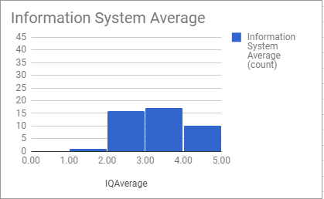
Figure 2: Information System Average

The use of the Information System average is 3.26. Based on the research findings, the results indicate that the UB students on an average ranked the Information System use more or less neutral, but tending to be slightly positive. Note Figure 1 that shows the results skewed to the right.

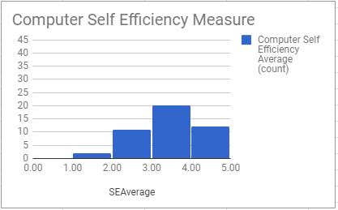
Figure 3: Computer Self Efficiency Measure Average
The Computer Self Efficiency Measure average is 3. 35 and is slightly skewed positive showing more of an asymmetrical distribution showing some variance.

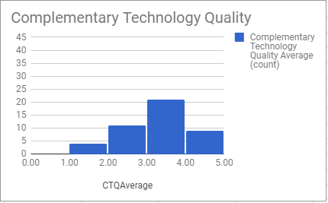
Figure 4: Complementary Technology Quality Average

The average for Complementary Technology Quality is 3.14, indicating more of a neutral average. The research findings also show a bell shape that shows some variance that is slightly skewed to the right.

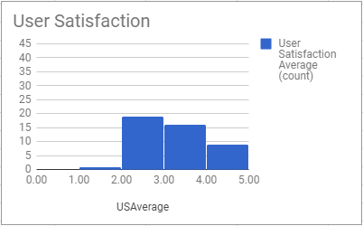
Figure 5: User Satisfaction Average

The User Satisfaction Average as it pertains to the use of Moodle is 3.22. The findings indicate a neutral User Satisfaction by UB student respondents. However, the findings also show that the results are significantly skewed right, indicating that students have more of a positive than negative user satisfaction, although there was a level of dissatisfaction.

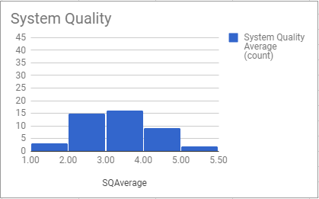
Figure 6: System Quality Average
Bell Shaped (Normal Curve)

The system quality average for Moodle, while the findings show a neutrality of 3.15, also points to significant variance. This shows that it is slight skewed to the left showing a negative correlation with service quality.

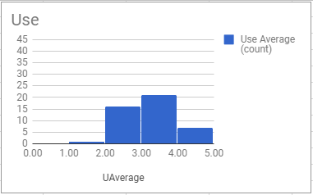
Figure 7: USE Average

The average use of Moodle is 3.21 indicating a neutral result with a skewed positive response for the use of Moodle. The results also indicate a slight negative response toward its use. Figure 6 is in the shape of a bell representing a normal curve.

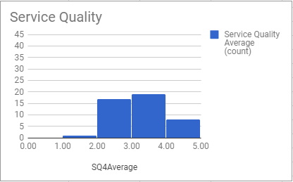
Figure 8: Service Quality Average

The research findings show an average ranking for Service Quality of Moodle as 3.22, that is, a neutral average, with a small skew toward the right. This suggests a positive response towards the service quality of Moodle. Figure 6 tends to be bell-shaped, although it is asymmetrical.

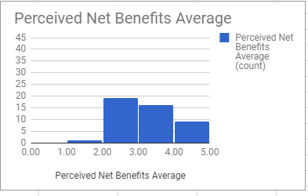
Figure 9: Perceived Net Benefits Average
The average for Perceived Net Benefits is 3.21 showing some variance and a skew toward the right, but with a mean showing more or less a neutral position.

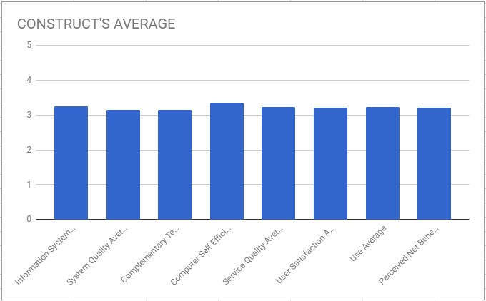
Figure 10: Construct’s Average
The eight elements that total the Construct’s Average are shown in Figure 9. Descriptively, the Average Construct is Uniform without outliers. The average is approximately just above 3.0.

Analysis of Findings/ Discussion

The overall Construct Average that showed an uniform result of a mean of just slightly above 3.0 out of 5.0, indicates that after computing and comparing the average results for all key areas of Moodle, that is, the: Information System, System Quality, Complementary Technology Quality, Service Quality, User Satisfaction, Use, and Perceived Net Benefits, that the responses toward Moodle by the University of Belize students were neutral. Overall, the responses indicated neither overall deep dissatisfaction nor high satisfaction for any of these service areas or resources.
In analyzing why the Information System is ranking at a neutral position of 3. 26 out of a ranking of 5, we might want to consider that the University of Belize (UB) has just made the use of Moodle’s use mandatory by both faculty and staff. It should be noted that students at UB include both associate and bachelor’s degree students; therefore, some students might not have the same computer background as other students who have been at UB and using Moodle already. Also, it is important to note that not all faculty use Moodle for assignments, etc., and that there are not many lecturers who use Moodle, and this might be impacting students’ use of the Information System.
In analyzing why the results for Computer Self-Efficiency averaged a mean of 3.35 out of 5, and which showed a lot of variance although there was a positive skew, the following variables are worthwhile considering: 1.) there is a large range of student age groups at UB; 2. Returning or mature students might not have the same computer hands-on experience like younger students who have been exposed to the latest technology using academic programs like Moodle; 3. A skew to the positive is that technology is becoming a way of everyday life and people are more open to experiment with its use; and, 4. It is probably not getting an overall high rating by students because the availability of working computer labs are still not meeting the needs of students.
Complementary Technology Quality showed a mean of 3.14 indicating a neutral position by UB students on rating complementary technology quality. The use of complementary technology involves ownership of mobiles, computers, as well as the technological resources that UB provides students by way of Internet service, computer labs, and mainframe Internet to student mobiles. Variables to consider would be whether students can access both the UB technological services easily. The result suggests that there is some limitation with the quality of the complementary services. While it is neutral, or suggests satisfaction with the services, it is not overwhelming so. The variance, though, shows that not all students have the same experience.
User Satisfaction averaged a mean of 3.22 indicating again that students were neither too satisfied nor dissatisfied with using Moodle. This question showed that students’ attitudes and expectations, while slightly tending toward a positive agreement, was more at the level of being satisfied. This could be tied into their experience with Moodle. It could be that not many of their lecturers have students using Moodle and this could be why they have not developed very positive attitudes or expectations of Moodle. Therefore, students’ responses could be tied into the lack of opportunity to use Moodle and their developing positive attitudes toward its use.
System Quality findings show a neutrality of 3.15; however the findings also point to significant variance. This shows that it is slight skewed to the left showing a negative correlation with service quality. This might account for why the responses for both the Complementary Technology Quality and User Satisfaction do not rate higher than a “Neutral” position, and do not rank on a “Strongly Agree” rating. If the service is perceived as not meeting students’ needs or if the resources are not in place, or if lecturers are not motivating students to use Moodle, this can all affect students’ perception of the System Quality.
USE of Moodle averaged a mean or “neutral” response by UB students who were asked to rate their frequency of use, dependency on it, knowledge of it, and ability to carry out tasks on their own. Like the responses on User Satisfaction and Information System and Self-Efficiency Measure, the average was a consistent “neutral” response. This could be attributed to the same reasons that are limiting the other key areas of Moodle examined. It would be useful to administer another questionnaire some six months from now and see if the results are the same. We must remember that this is the first year that Moodle has been made mandatory in the University. A questionnaire on USE for faculty would have also been able to provide data to understand how they are using/or not using Moodle.
The research findings show an average ranking for Service Quality of Moodle as 3.22, that is, a neutral average, with a small skew toward the right. This suggests a positive response towards the service quality of Moodle, although the findings show an asymmetrical bell with an indication of a level of dissatisfaction with the service quality.
The average for Perceived Net Benefits is 3.21 showing some variance and a skew toward the right, but with a mean showing more or less a neutral position. An important measure of whether Moodle is making an impact on UB students’ academic performance, their education goals, university financing (e.g. assisting with cutting down in printing), and in their assessments, this question obtained the same range of rating as the other questions: a “3” or a neutral position. It is the assumption that technology enables students to perform better at school than using traditional teaching and learning methods, but the results of this survey indicates that students themselves while they are satisfied with the technology, are not indicating any significant difference in how they are benefitting the technology as provided through the technology and Information System of Moodle.
In averaging the eight elements that total the Construct’s Average as shown in Figure 9, the Average Construct is Uniform without outliers. The average is approximately just above 3.0.
Overall, then, the survey showed that UB students are “neutral” in their rating of the Information System, Moodle and its overall elements. The findings of this survey are important because it can be used as an initial finding to the overall use of Moodle as it is being integrated into the curricula of University of Belize. A later study can track for changes in students’ experiences, practices in using Moodle, their attitudes, and in the development of UB technological resources.

Discussion, Recommendations and Limitations
This research has addressed the issue when it comes to the success of a management information system with reference to moodle. For this purpose A Learning Management System (LMS) model for success was developed by researchers. The development of this model relies solely on the creators, Delone and McLean(2003), however for the purpose of this study we included two more constructs that will make the study more applicable for a third world country. Hence, the model will use a combination of 8 constructs to illustrate the relevance of information quality, users satisfaction service quality, use, system quality, complimentary technology quality, computer self efficacy and perceived Net Benefits. These eight variable are measurement of the LMS success. After analyzing the LMS model carefully, it was observed that the variable, perceives net benefits holds a closer relationship to the LMS model as opposed to the remaining variables. Disintegrating this variable further with reference to the distributed surveys, but was seen that 95%of students at the University of Belize strongly agrees that the model helps to achieve their education objectives. Likewise, 75% agreed that using Moodle at school enhances their leaving ability. To further simplify, if the 7 other success variable of information quality, System quality, use, complementary technology quality, computer self efficacy, service quality, and users satisfaction are being managed both effectively and efficiently, the measurement of the perceived benefits success will be of greater value. The reason for this is because perceived net benefits should develop information that captures the relevance of perceived quality, service quality, complementary technology quality, computer self efficacy, users satisfaction and use. By doing this, management will begin to focus more on the development of both psychological and behavioral processes. In order for the University of Belize to fruitfully develop perceived net benefits, they need to properly implement the measures of information quality, complementary technology quality, system quality, and service quality. For example, in order for the University of Belize to gain success in its perceived benefits, the university needs to provide sufficient information on Moodle (open distance learning) and keep up dating Moodle- information quality. The university also needs to allow Moodle to be user friendly, easy to use, provide high speed information access, and also provides an interactive feature between users and the system quality. With the constant restraint at the University of Belize, the institution needs to encourage staff about the importance of using Moodle. This will allow the lecturers to be remain motivated to keep Moodle up to date, and shows interest to solve a problem that may arrive when a student has issues with using Moodle. Secondly in this model, system use was acknowledged to have a significant impact on the perceived benefits. The reason for this is because if a student does not have the necessary knowledge to use Moodle, depend on Moodle, then the perceived benefits of Moodle may start to diminish. Simply saying, that an increase in system use will yield more benefits without considering the nature of the “use” is insufficient (Delone and McLean,2003). Likewise, system use may be of great value because it strives to provide benefits to the students.
The findings clearly indicates that there is greater effect on information quality, use, user satisfaction, and perceived benefits. These measurements are substantially greater than those including system quality and service quality. The finding are in context with the LMS belief that clearly states that information quality holds a dominant influence on use, users satisfaction, and perceived net benefits. The beliefs hold a minority of that of system quality and service quality. After analyzing the distributed surveys, it showed that 96.6% of the respondents showed an interest and/or concern about Information quality (E.g. accuracy, understandability, completeness, relevance, and timeliness). To simplify, those who maintain Moodle needs to focus on promoting the effectiveness of their information quality.
The LMS provides a multidimensional model that illustrates the portrayal of dynamics surrounding but not limited to quality measures, satisfaction on evaluation, usage, and user perceived benefits. From a practical point of view, the model offers opportunities for organization to evaluate and predict the success of LMS. Based on our results, Moodle administrators can now be aware of what is necessary to improve the LMS and prioritize their investment accordingly.
Lastly, the limitations that exist within our research is that we used a random sampling of students from a single campus of the University of Belize, the Belize City campus. Sampling from a pool if students across campuses would have help with the generalization of our results. Another limitation is an observation made during the issuance of surveys, students were quickly responding to the questionnaire since they were focusing on other school duties at the time. Hence, this is another limitation for this research. However, despite our longing desire to generalize our results, our study provides true insight about our findings on the LMS success with Reference to Moodle.
To be brief, this study provides a structural understanding of not only of the LMS but the importance to up lift the information quality, use, and user satisfaction when using the open distance learning, Moodle in an organization.

References

Bhrommalee, P. (2012), “Students’ attitudes toward e-learning: A case study in a Thai university”, Clute Institute International Conference, pp. 567–577.

Bhuasiri, W., Xaymoungkhoun, O., Zo, H., Rho, J.J. and Ciganek, A.P. (2012), “Critical success factors for e-learning in developing countries: A comparative analysis between ICT experts and faculty”, Computers & Education, Vol. 58 No. 2, pp. 843–855.

Kanaracus, C. (2008). Gartner: global IT spending growth stable. InfoWorld April 3, 2008.
Mays Business School (2010, April 21). WHAT IS MIS? | MANAGEMENT INFORMATION SYSTEMS. Texas A&M University. Retrieved November 11, 2017.

Sebastian, D., Sebastian, W., and Torsten, E. (2013) Information Systems Success – A Quantitative Literature Review and Comparison. 11th International Conference on Wirtschaftsinformatik, 27th February – 01st March 2013, Leipzig, Germany.

Pitt LF, Watson RT and Kavan CB (1995) Service quality: a measure of information systems effectiveness. MIS Quarterly 19 (2), 173–187.

DeLone, W. H., & McLean, E. R. (2003). The DeLone and McLean Model of
Information Systems Success: A Ten-Year Update. Journal of Management
Information Systems

DeLone, W.H., and McLean, E.R. Information systems success:The quest for the dependent variable. Information Systems Research, 3, 1 (1992)

Rai, A.; Lang, S.S.; and Welker, R.B. Assessing the validity of IS success models: An
empirical test and theoretical analysis. Information Systems Research, 13, 1 (2002)

Seddon, P.B. A respecification and extension of the DeLone and McLean model of IS success. Information Systems Research, 8, 3 (1997)

Seddon, P.B., and Kiew, M.-Y. A partial test and development of the DeLone and McLean model of IS success. In J.I. DeGross, S.L. Huff, and M.C. Munro (eds.), Proceedings of the International Conference on Information Systems. Atlanta, GA: Association for Information Systems, 1994

