Measuring the Success 0f FAMCare at the Ministry of Human Development, Social Transformation and Poverty Alleviation
Completed Research Paper

Johan Petkau  University of Belize  Emerald, Belmopan  2015112364@ubstudents.edu.bz  Marcel Castro  University of Belize  17 Hummingbird Ave, Belmopan  2014111645@ubstudents.edu.bz | Emil Galdamez  University of Belize  Salvapan, Belmopan 2014110420@ubstudents.edu.bz  Marvin Sandoval  University of Belize  Caracol, Belmopan  2014110747@ubstudents.edu.bz
Abstract
In this paper, the Information Systems (IS) research on how developing Countries have attempted to benefit from Information and Communication Technologies (ICTs) will be discussed. This research focused on the FAMCare system. In relation to the FAMCare system, the System Quality, Information Quality, Use, User Satisfaction, Individual Impact and Organizational Impact, were measured in order to determine the success of the system. The Deleon and Mclean model were used in order to measure the success of FAMCare at the Ministry of Human Development. Results showed that FAMCare was a success at the Ministry.

Introduction
This article will focus on management information systems. The hardware and software components of management information systems are reviewed along with the type of organization functions for which applications software is designed to support. Management information systems are comprised of computing and communications hardware, operating system software, applications software to support business functions, and specialized staff to analyze and design systems that help to achieve business goals and objectives. Management information systems support a broad array of business operations and enable interaction with an organization's suppliers, customers and service providers. Our main objective and importance of our research topic is that we are trying to achieve and analyze if the Ministry of Human Development in the use of FAMCare, is appropriate to their work field and how does it helps close the gap between human needs and services. The origin of the project came about from the idea that FAMCare have already been launched in other countries in the Caribbean and it is the first time this system is been used here in Belize. We are trying to achieve how successful it is going to be for Human Development of Belize now that the system is implemented and how efficient their work and service will be. We have familiarized our self with the system and have come to concluded that FAMCare improves social worker effectiveness, measures, tracks and monitors your programs, staff and services to help you deliver a more community based, family-focused service system. But it is uncertain to us how effective FAMCare is for the Ministry of Human Development. Our objective is to measure the level of success after analyzing the data that was gather. Our Goals to gather as much information as possible so we can analyze and measure the program in a precise manner.

Literature Review
Numerous studies have been conducted over the past 15 years endeavoring to find the factors that contribute to information systems success. The dependent variable in these studies, however, has been a difficult one to define. Different researchers have addressed different aspects of success, making comparisons difficult and the view of building a cumulative tradition for I/S research similarly difficult to find. To organize this diverse research, as well as to present a more integrated view of the concept of I/S success, a comprehensive taxonomy is introduced. This taxonomy suggests six major dimensions or categories of I/S success: System Quality, Information Quality, Use, User Satisfaction, Individual Impact and Organizational Impact. Using these dimensions, both conceptual and empirical studies are then reviewed and organized according to the dimensions of the taxonomy. Finally, the many aspects of I/S success are drawn together into a descriptive model and its implications for future I/S research are discussed (DeLone & McLean, Information Systems Success: The Quest for the Dependent Variable, 1992).
System Quality: Measures of the Information Processing System Itself
In evaluating the contribution of information systems to the organization, some I/S researchers have studied the processing system itself. Swanson (1974) used several system quality items to measure MIS appreciation among user managers. His items included the reliability of the computer system, on-line response time, the ease of terminal use. and so forth. Emery (1971) also suggested measuring system characteristics, such as the content of the data base, aggregation of details, human factors, response time, and system accuracy (DeLone & McLean, Information Systems Success: The Quest for the Dependent Variable, 1992). Hamilton and Chervany (1981) proposed data currency, response time, turnaround time, data accuracy, reliability, completeness, system flexibility, and ease of use among others as part of a "formative evaluation" scheme to measure system quality (DeLone & McLean, 2003).
Information Quality: Measures of Information System Output
Apart from measuring the quality of the system performance, other 1/S researchers have preferred to focus on the quality of the information system output, the quality of the information that the system produces, primarily in the form of reports. Among their ten most important items, in descending order of importance, were information accuracy, output timeliness, reliability, completeness, relevance, precision, and currency (DeLone & McLean, Measuring e-Commerce Success: Applying the DeLone & McLean Information Systems Success Model, 2004).
Information Use: Recipient Consumption of the Output of an Information System
The use of information system reports, or of management science/operations research models, is one of the most frequently reported measures of the success of an information system or an MS/OR model. Several researchers (Lucas 1973; Schultz and Slevin 1975; Ein-Dor and Segev 1978; Ives, Hamilton, and Davis 1980; Hamilton and Chervany 1981) have proposed I/S use as an MIS success measure in conceptual MIS articles. In addition to these conceptual studies, the use of an information system has often been the MIS success measure of choice in MIS empirical research (DeLone & McLean, Information Systems Success: The Quest for the Dependent Variable, 1992).
User Satisfaction: Recipient Response to the Use of the Output of an Information System
Successful interaction by management with the information system can be measured in terms of user satisfaction. Several I/S researchers have suggested user satisfaction as a success measure for their empirical I/S research. These researchers have found user satisfaction as especially appropriate when a specific information system was involved. A key issue is “whose” satisfaction should be measured. In a study by Lucas (1978), sales representatives rated their satisfaction with a new computer system. Later, in a different study, executives were asked in a laboratory setting to rate their enjoyment and satisfaction with an information system which aided decisions relating to an inventory ordering problem (DeLone & McLean, Information Systems Success: The Quest for the Dependent Variable, 1992).
Individual Impact: The Effect of information on the Behavior of the Recipient
Individual Impact is closely related to performance, and could also be an indication that an information system has given the user a better understanding of the decision context, has improved his or her decision-making productivity, has produced a change in user activity, or has changed the decision maker's perception of the importance or usefulness of the information system. Mason (1978) has suggested that one method of measuring I/S impact is to determine whether the output of the system causes the receiver (i.e., the decision maker) to change his or her behavior. Other researchers have gone a step further by asking respondents to place a dollar value on the information received (DeLone & McLean, Information Systems Success: The Quest for the Dependent Variable, 1992).
Organizational Impact: The Effect of Information on Organizational Performance
Measures of individual performance and, to a greater extent, organization performance are of considerable importance to I/S practitioners. Rivard and Huff (1984) interviewed data processing executives and asked them to assess the cost reductions and company profits realized from specific user-developed application programs. Lucas (1973) and Hamilton and Chervany (1981) suggested that company revenues can also be improved by computer-based information systems. More comprehensive studies of the effect of computers on an organization include both revenue and cost issues, within a cost/benefit analysis (Emery 1971). McFadden (1977) developed and demonstrated a detailed computer cost/benefit analysis using a mail order business as an example. Another measure of organizational performance which might be appropriate for measuring the contribution of MIS is return on investment (DeLone & McLean, Information Systems Success: The Quest for the Dependent Variable, 1992).

Methodology
Research Participants
The target population for this research will be workers from the Ministry of Human Development of Belize, which included all workers that are using FAMCare. The sampling technique that will be utilized is convenience sampling; therefore, all workers that part take will be conveniently selected. The researcher will select workers who are easy to reach, the selection will occur during working hour which is on Monday- Friday at 8:30-4:00 p.m. as workers are in their office. The sample will consist of workers that are working at the Ministry of Human Development of Belize only. The number of samples distributed will be 50 questionnaires, which consist of statements close ended question only.
Design
The research is aimed to simply see the Success of FAMCare, specifically FAMCare user’s perspectives from the Ministry of Human Development of Belize. The research and the fieldwork will be carried out from September to November 2017. The research has only one component, being a worker's opinion questionnaire. The method being used for this Research is a mixed methodology. However, these questions will consist of only closed ended questions; close ended questions such as to measure the system quality, complementary technology quality, user satisfaction, and information quality. The questionnaire will be distributed to Ministry of Human Development workers who are currently employed. It will also be focused on the criterion validity which will be used to interpret the success of FAMCare, if the results from the survey can form a relationship or are related in any way possible. Moreover, the researchers will insure that the strategy is reliable and valid by the variables being used in this specific research.
Apparatus or Instruments
The instruments that will be used to collect the data are questionnaires. The reliability of this instrument will include the inter-rater reliability which refers to statistical measurements that determine how similar the data collected by different raters are. To determine the validity of the research, the researchers will focus on the criterion validity. Criterion validity measures how well one measure predicts an outcome for another measure. The questionnaire results will focus on the criterion validity which will be used to see if the information quality and system quality is one of the fundamental variables contributing to the success of FAMCare or related to one another in any way possible. In this research, the dependent variable that will be measured the success of FAMCare. Defiantly if the results are similar from all the questionnaire we can come with some conclusion that FAMCare is success or not success in Ministry of Human Development.

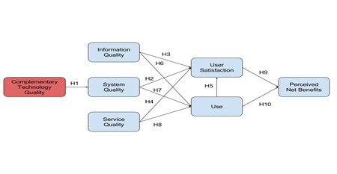
Figure 1

Hypothesis:
H1. Complementary technology quality will positively impact system quality.
H2. System quality will positively impact user satisfaction.
H3. Information quality will positively impact user satisfaction.
H4. Service quality will positively impact user satisfaction.
H5. Use will positively impact user satisfaction.
H6. Information quality will positively impact use.
H7. System quality will positively impact use.
H8. Service quality will positively impact use.
H9. User satisfaction will positively impact perceived net benefit.
H10.Use will positively impact perceived net benefit.
Sampling and Data Collection
The data for this research were collected from a sample of the Ministry of Human Development. The method of the research sampling was convenient sampling. The survey was emailed to all users of FAMCare all over Belize. A total of 52 surveys were collected and analyzed. For convenience, Google Forms was used to hand out the surveys.
Characteristic of Respondents

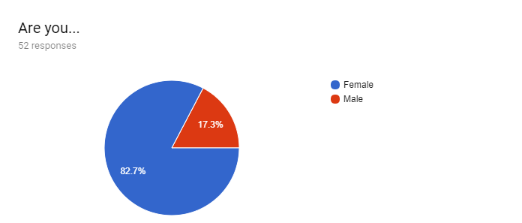
In our research topic, we can see that most of FAMCare users were Females. 82.7% were females and 17.3% were males.
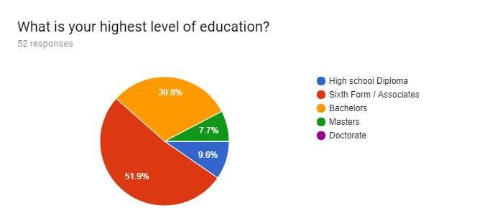
In this pie-chart, we can analyze that most of the FAMCare users have an Associate's degree and a Bachelor’s Degree. Few of the FAMCare users has an Master or a diploma.

Information Quality
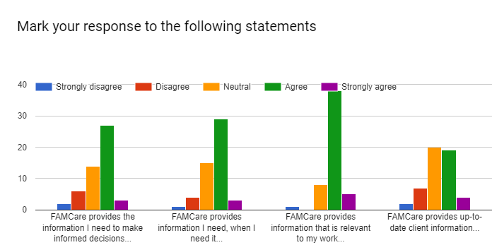
According to the bar chart, FAMCare user were satisfied with the system. They agree that FAMCare provides the information needed to make informed decision, provides information when they need it, and provides information that is relevant to their work. However, FAMCare users were mostly neutral with the up-to-date client information.
System Quality
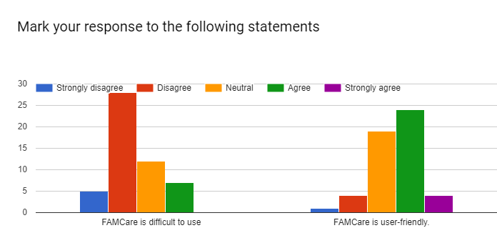
In this chart shown above, we can see that FAMCare is not difficult to use, instead FAMCare is a user-friendly.
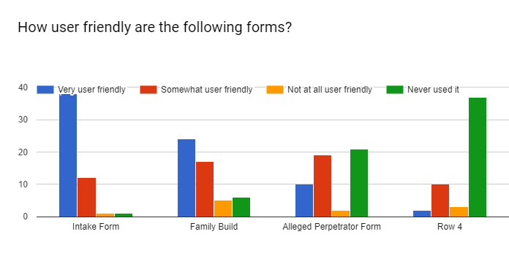
As seen above, the intake form and family build are very user friendly, while alleged perpetrator form and row 4 most of the FAMCare user have never used it.

Complimentary Technology
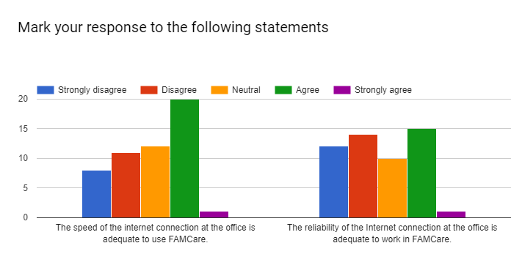

On this bar chart, most of the FAMCare user agree that the speed of the internet connection at the office is adequate. The reliability of the internet connection at the office is adequate to work in FAMCare, there is a slight difference of the FAMCare user disagreement and agreement.
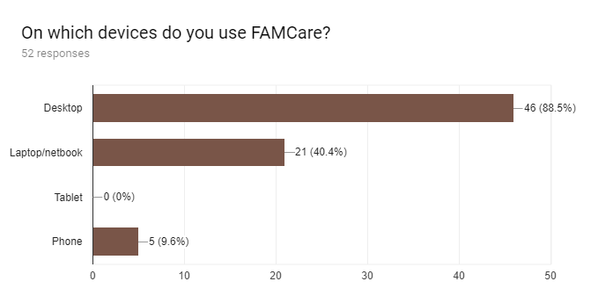

The chart shown above, illustrates on which devices the FAMCare system is used. There are 3 devices they used which are: desktop, laptop/netbook, and phone. We have 88.5% FAMCare users using the system by their desktop, 40.4% on their laptop/notebook, and 9.6% on their phone. Therefore, we can see that most FAMCare user use a desktop device.

Computer Self-Efficacy Measure
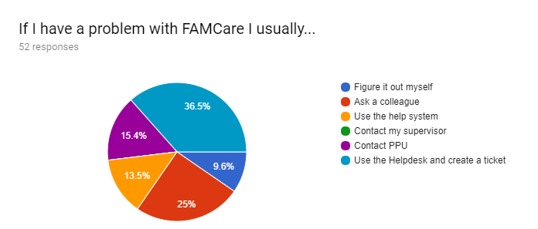
As seen above, if FAMCare user have a problem with the system, majority of them usually use the helpdesk and create a ticket or ask a colleague. Others contact PPU, use help system, and barely of them figure it out by themselves.
Service Quality
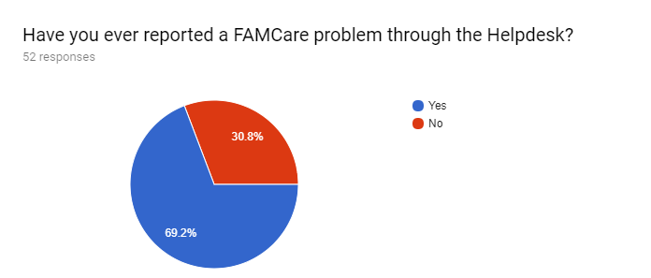
These pie chart illustrate the percent of the FAMCare users that report a FAMCare problem through the helpdesk. We have 69.2% users that have reported it and 30.8% users that have not make a report of a FAMCare problem through the helpdesk.
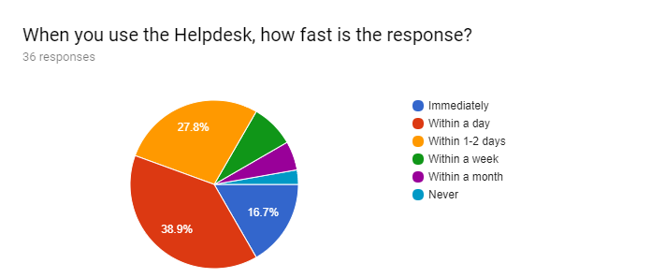
As shown above, majority of FAMCare users says that they get within a day the response when they use the helpdesk. Other users stated that they get their response within 1-2 days or immediately.
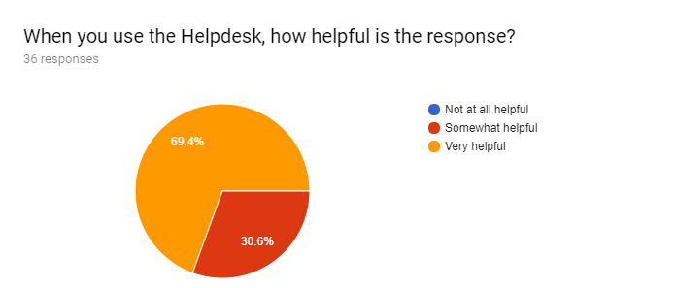
According to the pie chart, we can see that the responses received from Helpdesk are quite helpful.

User Satisfaction
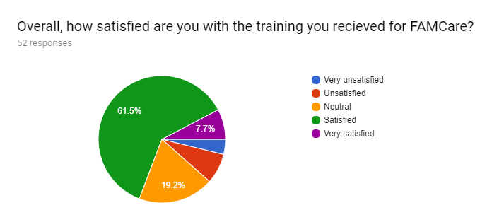
As seen above, FAMCare users were satisfied with the training they are receiving for FAMCare.
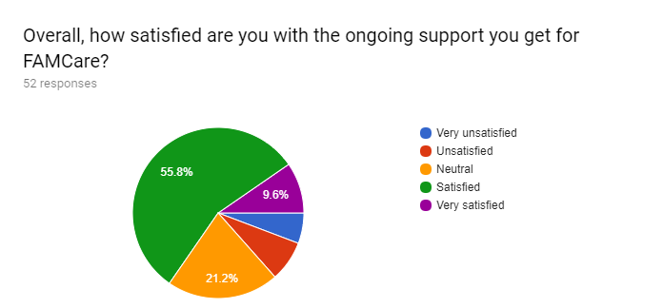
These pie chart illustrate that majority of the FAMCare users were satisfied with the ongoing support they get for FAMCare.
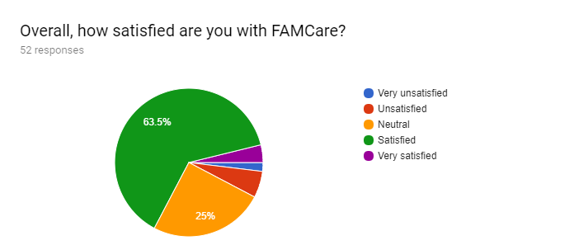

From this chart, we can see that most FAMCare users are satisfied with the system. A quarter of them were neutral about it. Only a few users were dissatisfied.

Use
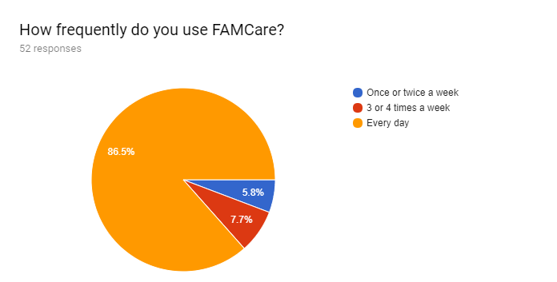

As seen above, majority of FAMCare users use FAMCare every day. We also have a few users that use FAMCare 3 or 4 times a week or once or twice a week.
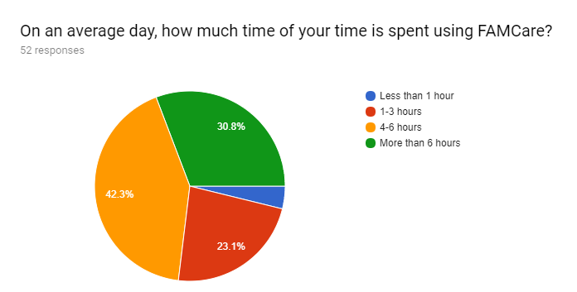

The pie chart shows time users spend on FAMCare. Most users spend a lot of time on FAMCare on an average day.

Perceived Net Benefits
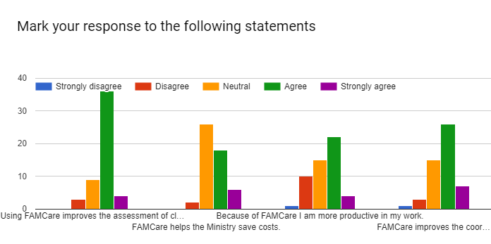
This graph show that most users appreciate the system. While they were neutral about it saving the ministry cost, most of them believed that the system improved client assessments, improved personal productivity and improved the coordination between departments.

Conclusion
Implications
This research has addressed the way in which FAMCare has been successful at the Ministry of Human Development. FAMCare provided an information system which made the ministry for efficient in their everyday work. The results also show that information quality, service quality and user satisfaction are important benefits that measures FAMCare success. The study shows that most FAMCare users are satisfied with FAMCare when it came to providing them with the proper information needed to work on daily basis. Users now have the privilege of working with software technology versus previous paper work.
While FAMCare helped in eliminating paper work, users do have some difficulty with the software’s minor bugs. These problems however, were quickly attended to through the use of “Helpdesk.” When FAMCare users came across a problem, “Helpdesk” was able to solve 85% of user’s problems. 12.5% of users stated that the system could still use some fixing. Only a minor 2.5% stated that their problem was never solved.
In addition, FAMCare usage is extremely high because it is the most efficient way for social workers to handle human cases. 86.5% of users stated that they use FAMCare on a daily basis. 7.7% stated that they use is 3 to 4 times a week. Moving on from their daily use, 30.8% stated that on a daily basis, they spent more than 6 hours on FAMCare. 42.3% stated 4-6 hours and 23.1% used FAMCare 1-3 hours. Apart from the usage, FAMCare users stated that the system improved client assessment, helped the ministry save costs and improved the coordination between departments.
Limitations
The researchers did not encounter any sort of limitation while conducting this research. The Ministry of Human Development was willing to assist the researchers in handing out the survey. Respondents collaborated well in filling out this survey by responding in a timely manner. In total 52 surveys were answered.

Recommendation

Based on the findings of this study conducted on the perspectives Measuring the Success 0f FAMCare at the Ministry of Human Development in Belize, the researchers proposed the following recommendations. First, we would recommend Offline saving. This is due to the fact that when the internet is not working well, saving of information is difficult for the Users of FAMCare. Secondly, we would recommend automatic Update since many users said that majority of times information is not save in the system. Lastly, we would recommend more use of tabs without going to homepage to open multiple pages. On account many users said if they wanted to open multiple pages they had to go back to home page. For example, if they wanted to open a progress note and a family plan at the same time the system did not allows them to do so. Over all Users are satisfy with FAMCare System.

References
DeLone, W. H., & McLean, E. R. (2003). The DeLone and McLean Model of Information Systems Success: A Ten-Year Update. Sharpe. Inc.
DeLone, W., & McLean, E. (2004). Measuring e-Commerce Success: Applying the DeLone & McLean Information Systems Success Model. Sharpe, Inc.
DeLone, W., & McLean, E. R. (1992). Information Systems Success: The Quest for the Dependent Variable. The Institute of Management Science.
Dông, P. T. (2014). Education Research.
Halonen, R., Acton, T., Golden, W., & Conboy, K. (n.d.). DELONE&MCLEAN SUCCESS MODEL AS A DESCRIPTIVE TOOL IN EVALUATING A VIRTUAL LEARNING ENVIRONMENT. Galway: National University of Ireland.
HSIU-FEN LIN. (2007). Measuring Online Learning Systems Success: Applying the Updated DeLone and McLean Model. Keelung: Mary Ann Liebert, Inc.
Miss, M. B. (2014). INFORMATION SYSTEMS USER SATISFACTION: A SURVEY OF THE POSTGRADUATE SCHOOL PORTAL, UNIVERSITY OF IBADAN, NIGERIA. Ibadan: University of Nebraska.

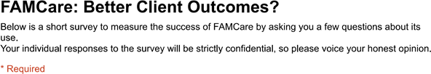
Appendix
