Evaluation of the NEO Municipalities Information System

Carla Lopez  Faculty of Management and Social  Sciences  University of Belize, Belmopan  carla.estefanie.lopez@gmail.com | Yancy Nabet  Faculty of Management and Social  Sciences  University of Belize, Belmopan  yancynabet@yahoo.com
Melisa Garcia  Faculty of Management and Social  Sciences  University of Belize, Belmopan  melisagarcia4ever@gmail.com | Anita Ack  Faculty of Management and Social  Sciences  University of Belize, Belmopan  anita.ack@gmail.com

Abstract

The NEO Municipalities Information System has become the second municipal Information System introduced to Belize, escalating to a new level of municipal management from August 2017. This system is an integrated management system that takes into account all the operations of the council including the HR management. The purpose of the research on NEO Municipalities is to evaluate as well measure the effectiveness and efficiency of the Information System. As its potential is to allow communication among the different municipalities throughout the country achieving a point in which everything becomes virtual global, where one doesn’t necessarily have to physically be at a particular location to get things done. Providing the government with faster accessibility to everything that is occurring in all the municipals throughout Belize.

Keywords: NEO Municipalities, information systems, municipalities, histogram results

Introduction
The adoption of information technology (IT) in organizations has been growing at a rapid pace. The use of the technology has evolved from the automation of structured processes to systems that are truly revolutionary in that they introduce change into fundamental business procedures. (The impact of information systems on organizations and markets, 1991) Information Systems emerged in the early 1980, these systems are a “combination of hardware, software, infrastructure and trained personnel organized to facilitate planning, control, coordination, and decision making in an organization.” (What is Information System?, n.d.)

Both the private and public sector uses Information Systems. These systems support organizations maintain “competitive survival and ongoing sustenance of an organization primarily depend on its ability to redefine and adopt continuously goals, purposes and its way of doing things.” (Ndou, 2004) Moreover, these trends stated previously suggest that private and public organizations have to reinvent themselves through ‘continuous non-linear innovation’ in order to sustain themselves and achieve strategic competitive advantage. (Ndou, 2004) However, its only until recently according to Ndou, that the public- sector has recognize the potential importance of Information & Communication Technology and e-business models as a means of improving the quality and responsiveness of the services they provide to their citizens, expanding the reach and accessibility of their services and public infrastructure and allowing citizens to experience a faster and more transparent form of access to government services. (Ndou, 2004)

When it comes to Belize, the country is not entirely espoused to information technology. However, as the country progesses the Government has realized the necessity of incorporating Information Systems. Even though, mostly of it processes still remain manual. As it gradually shifts however, the Government of Belize should be aware that not all Information Systems are successful in developing countries due to drawbacks such as “unrealistic objectives and goals, inadequate human resources to support the effort and inappropriate development methodologies used to build the system.” (Specific issues concerning the application of information systems in developing countries, n.d.) The main objective of this research is to evaluate the effectiveness and efficiency internal use of NEO Municipalities Information System. This system was introduced to the city and town councils throughout Belize August 2017. Individuals using this Information System are: mayors, administration departments, cashiers, revenue and clerk managers. NEO Municipalities is a customized integrated management software specifically for Municipal management. The primary purpose of this Information System is to include management data and revenue for accounts being use such as trade licenses, property tax and vehicles fees. Moreover, this system manages arrangement for payments and assist in budgeting. This Information System is also intended for the use of the public in the future. The citizens will have the access to their personal information for instance viewing outstanding fees without actually going to his or her corresponding municipality. Thus, the importance for evaluation of the Information System.

Originality

The originality of this research is to measure the success of the municipal Information System: NEO Municipalities in Belize. Since there is no empirical test using the IS Success Model to validate its level of effectiveness and efficiency.

Literature Review
City and town councils are the legislative bodies that govern a city, town, municipality or local government area. They have various functions in the community such as: maintenance of parks, drains and public cemeteries that are carried through revenues collected by government from the public.
As the population increases the manual processes carried through the daily routines by the city and town councils have become more tedious and time consuming. It requires a great deal of time: collecting, filing and making sure that the information is being placed with the correct citizen file that have drawbacks on the municipal being efficient and effective.

Thus, the emergence of Information Systems specifically customized to assist municipalities. Information system have “developed e-Administration – for automation and computerization of administrative tasks and for realization of strategic connections among internal processes, departments and functions.” (Ndou, 2004) Moreover, Information systems assists “developing countries, especially, the public sector playing a comparatively far greater role –measured, for example, in terms of contribution to GDP or to total employment.” (Heeks, 2002)

To measure the success of Information System the DeLone and McLean Success Model is used. The D&M’s (1992) comprehensive review of empirical literature represents an important step towards consolidating our knowledge of IS success measures. (Seddon, 1997). Whenever systems are being evaluated, it is best to talk about the efficiency it has brought to the organization. The DeLone and McLean (1992) initial attempt on the paper was ‘to bring awareness and structure to the “dependent variable” –information systems success- in IS research.’ (DeLone, W. H., & McLean, E. R., 2002) They wanted to incorporate a framework to implement an interactive and categorized model for reviewing the IS success and was later known as the D&M IS Success Model. Along with this, their model was refereed over 150 instances that applied the model of IS success. The D&M IS Success Model showed complete evidence that IS research needs comprehensive frameworks to operate as one. Along with communication researchers, Shannon and Weaver (1949) and Mason (1989), a suggestion of six comprehensive, multinational dimension of IS success was brought up to the table. They are: ‘System Quality’, ‘Information Quality’, ‘Use’, ‘User Satisfaction’, ‘Individual Impact’ and ‘Organisational Impact’. This structure is the base of succession for an effective evaluation of an Information System (IS). The exclusive purpose of this model is the practicality of its outline when developing and proposing an IS for a specified field such as e-commerce. The model is inclusive of behavioral awareness on persons using the interchanged IS observing the changes in behavior of the user and to what extent it is influencing job roles.
However, before these suggestions of the six multinational dimensions, there were critiques to the D&M IS Success Model which led to failure for their main use of the IS Model was for support rather than for illumination. They misunderstood the main purpose of it which led to analyze the interrelationships amongst the dimensions. DeLone and McLean stated, “researchers should systematically combine individual measures from the IS success categories to create a comprehensive measurement instrument”. (DeLone, W. H., & McLean, E. R., 2002)

Moreover, a number of theories and models have been proposed to explain acceptance of Information System (ISs) as well. Literature considers all end users standardized, more skilled and ready to use (MIS) however the Government system sees them as diverse users, some skilled and others illiterate as in the case of the elderly and less educated people, or knowing just basics. Therefore, these users that are not as familiar to the technology, so they will encounter problems while interacting with e-Government systems. (Al-Khatib & Lee, 2011)
This study will be using the DeLone and McLean model to measure the success of NEO municipal edition that was implemented in August 2017. The six guidelines shave been used along with data to come up with true evaluation of the newly implemented system at the Municipalities within Belize. After applying the IS Success Model we found it difficult as the six guidelines used were quantity and more consummation rather than evaluating two variables of the same capacity. Therefore, using different graphs to show the “system quality” with “user satisfaction” then “individual impact,” between “information quality” with “user satisfaction” and “individual impact,” and between “user satisfaction” and “individual impact.” Rai et al. To test the conclusion that IS success model is significant and true in this paper.

Research Model/Hypothesis
The DeLone and McLean Model of Information Systems Success: A Ten-year Update was introduced in 1992. This IS Success Model intended to bring some awareness and structure to the “dependent variable”—IS success—in IS research. It proposed a taxonomy and an interactive model (hereafter referred to as the “D&M IS Success Model”) as frameworks for conceptualizing and operationalizing IS success.” (Delone & McLean, 2003) Later on, DeLone and McLean reassessed the existing terms of IS success as well as the distinctive measures classifying into six dimensions that are: System Quality, Information Quality, Use, User Satisfaction, Individual Impact, and Organizational Impact. The D&M Is Success Model and the six dimensions’ focuses on a process model of information systems which ‘merely states that B follows A’ (DeLone, W. H., & McLean, E. R., 2002).

Information Quality dimension “measures in terms of accuracy, timeliness, completeness, relevance, and consistency.” (Delone & McLean, 2003) System Quality “measures in terms of ease-of-use, functionality, reliability, flexibility, data quality, portability, integration, and importance.” (Delone & McLean, 2003) Service quality incorporated after the emergence of end user computing in mid 1980s. This was added to prevent “mismeasure of IS effectiveness if they do not include in their assessment package a measure of IS service quality” since most use measures focused only on products excluding services. (Delone & McLean, 2003) Service Quality dimension measures responsiveness, reliability, competence, attitude and accuracy. Moreover, the D&M IS Success Model encompass User and User Satisfaction dimensions. This is important since it measures overall IS success. It measures “frequency of use, time of use, number of accesses, usage pattern, and dependency.” (Delone & McLean, 2003) Moreover, IS Use and User Satisfaction are two of the most used variables in the model for the use of measuring the success of the research; it has been finalized that the greater level of positivity of system quality and user satisfaction determines how frequent the system is being used. These dimensions all lead to Net Benefits. Net Benefits encompass the impacts of IS have on the users and organization on a whole. Moreover, Net Benefits are the most vital success measures as they retrieve the balance of positive and negative impacts. Depending on the results from the user using the information system it will reinforce or diminish the dimensions: User and User Satisfaction.
In figure 1 illustrates the DeLone and McLean IS Success Model interrelation among the dimensions. Furthermore, D&M IS Success Model has been updated in 2003 and 2004 being referred in over “300 articles in refereed journals and made use of, this IS Success Model.” (Delone & McLean, 2003)
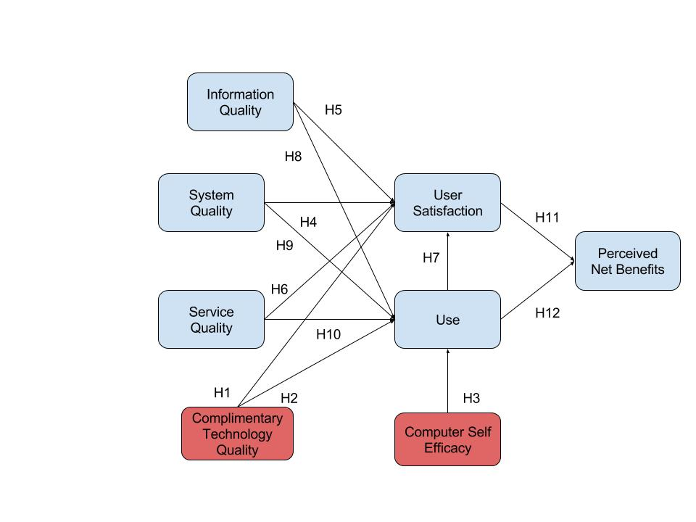
Figure 1 DeLone and McLean's Information System Success Model

Nevertheless, something to note that when published in 1992 the D&M IS Success Model was not tested empirically yet, multiple studies have undertaken empirical investigations providing propose advancement and validation among others. Through the evaluation provided “minor refinements to the model and propose an updated DeLone and McLean IS Success Model.” (Delone & McLean, 2003)

The hypothesized relationship between NEO Municipalities Information System are based on theoretical and empirical work done by Delone and McLean Information System Success. It encompasses the following twelve hypotheses that are:

H1. Complementary technology quality will positively impact user satisfaction.
H2. Complementary technology quality will positively impact system use.
H3. Computer self-efficacy will positively impact system use.
H4. System quality will positively impact user satisfaction.
H5. Information quality will positively impact user satisfaction.
H6. Service quality will positively impact user satisfaction.
H7. Information quality will positively impact use.
H8. Information quality will positively impact use.
H9. System quality will positively impact use.
H10. Service quality will positively impact use.
H11. User satisfaction will positively impact perceived net benefit.
H12. Use will positively impact perceived net benefit.

Methodology/Research Design
Due to the time constraint and the short period of the research, the researchers piloted a quantitative examination. The research is based on the success of the NEO Municipalities information system. It is a tailored system that was developed for the city and town councils. Therefore, the individuals who would have access and first-hand knowledge to this newly integrated system are those who are employed in the collections, revenue and traffic department. This system is just in its first phase so there are limited personnel’s that use this system. A three-page questionnaire was distributed to the five municipalities that have implemented the system. However due to location only four councils were surveyed. These councils were Benque Viejo Del Carmen, San Ignacio, Belmopan and Belize City. Corozal was the one that wasn’t surveyed.
The study focused on the councils that had the system implemented and in use already. The total municipalities that have started using the NEO Information System in the country are the population. So, the sample was not random as only a small percentage of the council’s employees are using NEO. A total of 32 questionnaires were disseminated, with just 27 of that amount answered. The requirement to answer the questionnaire was that the partakers were familiar with the system and had access, and that they also worked directly with the information system. The questionnaire used can be found in the appendix. The basis of each construct is as follows:

Table 1. Construct and Source
Construct | Source
Information Quality | Bailey and Person (1983)
System Quality | Alshibly (2011)
Service Quality | Chang et al, (2009)
User Satisfaction | Seddon Yip (1992)
Use | Balaban et al., (2013) Rai et al, (2002)
Perceived Net Benefits | Alshibly (2011); Tansley et al (2001)
Complementary Technology Quality | Teece, D. J. (1988)

Data Analysis and Results

The chief purpose of the study was to measure the effectiveness or success of the NEO Municipal Information System. The figures shown for this study were collected from four out of five municipalities that are already using the new system.
Of the 32 questionnaires that was disseminated to the five municipalities, four answered with the persons that used the system. So, 27 usable surveys were retained and used, thus yielding a response rate of about 84 percent. This passed the 50 percent mark, so it was considered satisfactory. The respondents' characteristics are shown in Table 2. Male partakers indicated a slightly lower percentage of the completed sample which is approximately 44% the female participants were approximately 55% so it was not much of a difference between the genders. Moving on to age, it showed that 51.86% of the participants were aged over 35-45 years. Suggesting most of the persons in this study are middle aged, and may possibly have already been accustom to another norm. The sample indicated that almost 50% were high school graduates, approximately 25% had an Associate's Degree. The participants were not as experienced or versed with this newly implemented system nor the previous system; it showed that approximately 59% of the partakers had less than 5 years’ work experience.

Table 2. Characteristics of Respondents
Characteristics | Number | Percentage
Gender
Male | 12 | 44.4%
Female | 15 | 55.6%
Age
Less than 25
From 25-35 | 3 | 11.11%
Over 35-45 | 14 | 51.86%
Over 45-55 | 6 | 22.22%
Older than 55 | 4 | 14.81%
Education
Primary School | 1 | 3.70%
High School | 13 | 48.15%
Associates | 7 | 25.93%
Bachelors | 6 | 22.22%
Masters | 0
PhD | 0
Working Experience
Less than 5 | 16 | 59.27%
From 5-10 | 6 | 22.22%
Over 10-15 | 4 | 14.81%
More than 15 | 1 | 3.70%

Below are Histograms showing the outcomes of the questionnaires collected from the respondents regarding the success of the NEO Municipalities Information System. The questions were based on DeLone and McLean model theory framework which included Information Quality, System Quality, Complementary Technology Quality, Service Quality, User Satisfaction, Use and Perceived Net Benefit.

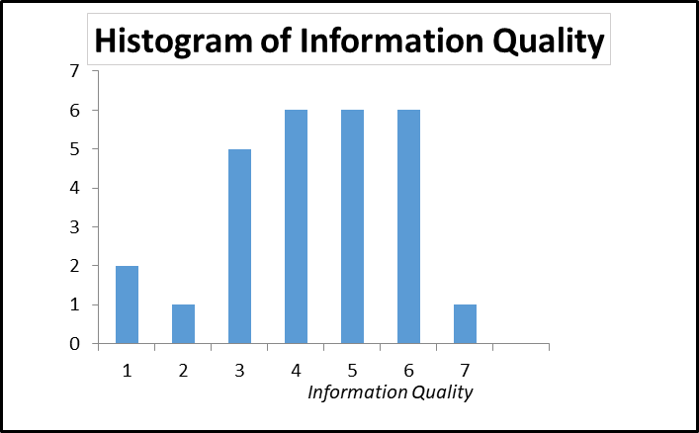
Figure 2. Histogram of Information Quality

Figure 2 illustrates that the Information Quality of the information system is decent in terms of providing up to date information.

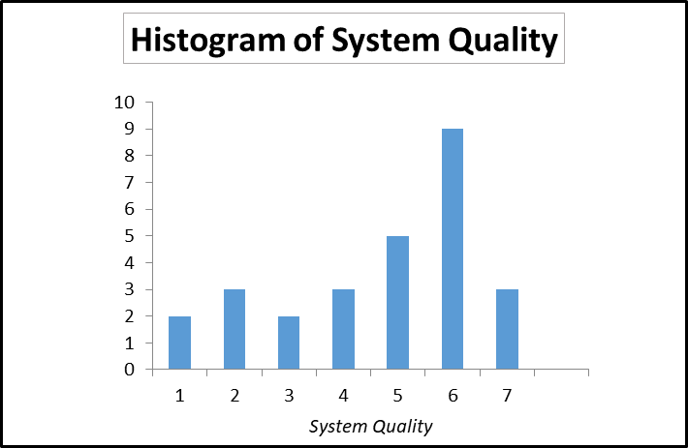
Figure 3. Histogram of Service Quality

Figure 3 demonstrates that most of the respondents agree that the System Quality is good as it relates to the software and procedural and provides sufficient information.

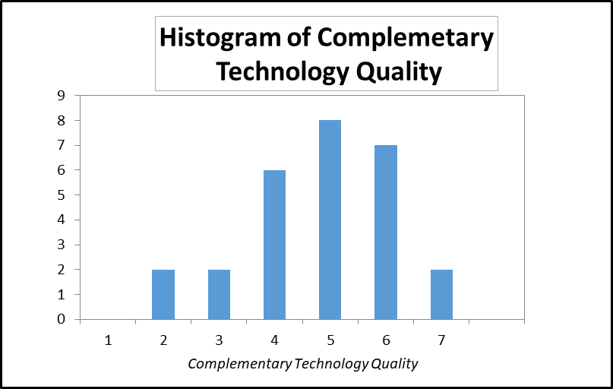
Figure 4. Histogram of Computer Self Efficacy Measure

Figure 4 illustrates that majority of the respondents agree that the computers being used is adequate in the functionality of criterions needed to operate the system.

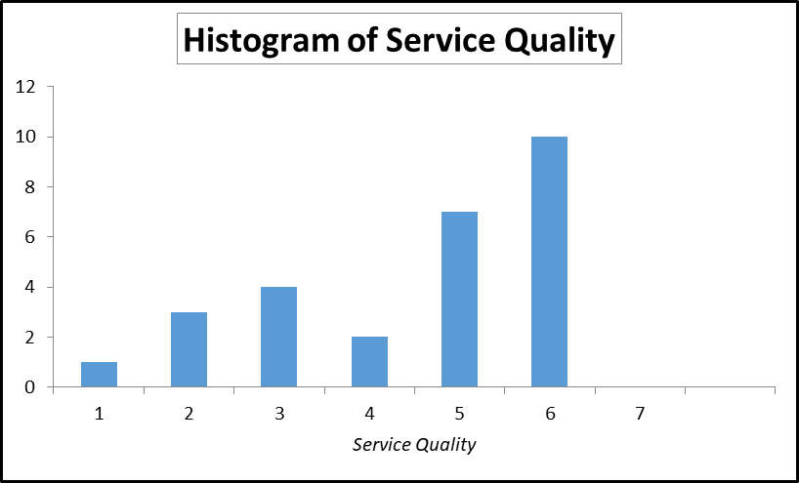
Figure 5. Histogram of Service Quality

Figure 5 demonstrates that most of the respondents are satisfied with the service quality of the software being used and that is up to date. The remainder evaluated the service quality low because whenever an issue arise the support staff which is EDATA would have to be contacted and the problem be fixed remotely. This then let the user lose time in waiting for the updated version of the information needed.

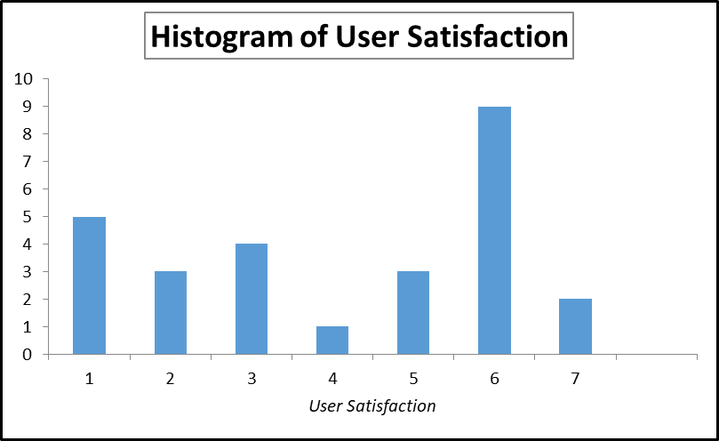
Figure 6. Histogram of User Satisfaction

Figure 6 portrays the use of the NEO Municipal System as high as the system is highly depended on to get work done. However, the remainder of the persons being surveyed did not find it to be dependable and couldn’t complete simple tasks such as running a report.

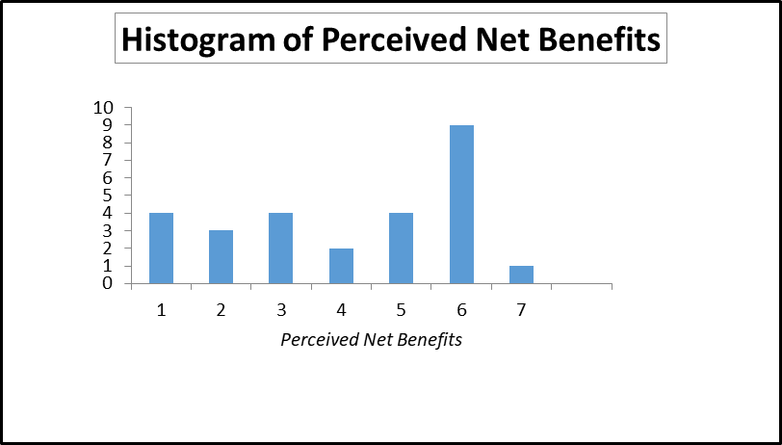
Figure 7. Histogram of Perceived Net Benefits

Figure 7 shows that less than half of the respondents agree that the NEO Municipal information system aids both them and the clients. The data shows that they believe their overall productivity is reduced in the workplace as little training is provided for the achievement of organizational goals.
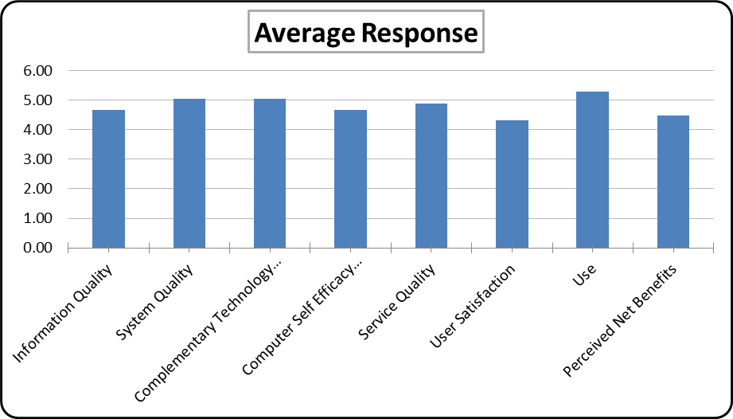
Figure 8. Average Response

Figure 8 demonstrates the general responses of the NEO Municipal Information System model. Therefore, System Quality and Complementary Technology was rated good. While Information Quality, User Satisfaction and the computer self- efficacy cored very low. Consequently, it is concluded that the overall perceived net benefit of using the newly implemented NEO Municipal Information System is satisfactory.

Discussion and Conclusion

Discussion
This research was conducted to measure the success rate of the NEO Municipalities Information System. To measure the success rate was based on the DeLone and McLean IS Model. The results measured Information Quality, System Quality, Complementary Technology, Computer Self Efficacy, Service Quality, User Satisfaction, Use and Perceived Benefits.

After the completion of the research the data collected it provide an insight how successful is the information system. According to the histograms the results show the opposite as the proposed measures. However, factors that can influence not meeting proposed measures since 48.15% is made up of high school graduates. That could suggest that they not have the enough knowledge of the impacts of an information system. Also, the age range plays another key role since must users are above 35 years and may not be technologically updated hence, viewing the information system as a burden and negatively.

Conclusion
In our research we established that of all the participants that were surveyed they found the NEO Municipal Information System to be satisfactory. The scores went up to an average of five which would indicate that the system quality and use was good. Based on the chart examination we concluded that either the information system does not have all the requirements needed to complete a task or the more mature workers which were the majority, showing them to be over fifty percent have gotten used to the previous and still functioning system which is the HASAL system.
It was noted that while some contributors to the survey appraised some parts a little higher with not much significance in difference for the overall system to be perceived as good. Therefore, our recommendation would be to discontinue use of the system until Phase one of it is fully completed and proper training can be initiated by the developers of the software. As the “old” system is still being used as a backup if something goes wrong with the NEO system which lets the users work redundant as all information have to be inputted twice. In addition to updating the systems to have the information the data had to be checked and some were incorrect. So, a proper run of all data from the previous system to this NEO municipal edition is vital. The proposed suggestions are vital as without the proper training and functionality of the system, the day to day operations of the municipalities would fail or the process would take too long to do, thus showing ineffectiveness and not upholding the organizational goals. Most importantly if the system does not function properly the work would have to be inputted manually which again is not time efficient.
The main focus of the Government of Belize, specifically the Municipalities, is to be able to attain accurate data. Our research done using the DeLone and MacLean Model to attain outcome of this project. Testing if the Information system is a success using the seven constructs aided us to understand where the NEO Municipal information is insufficient and how these inadequacies can be improved in the immediate future. This can then indicate the possibility and show potential of what the NEO Information System will be able to achieve. It is noted that its main goal is to provide virtual global services and communication among municipalities and obtain an overall view of transactions right from one’s office or home.

References
Al-Khatib, H., & Lee, H. (2011). INTERNATIONAL JOURNAL OF eBUSINESS AND eGOVERNMENT STUDIES. Middlesex, Uxbridge.
DeLone, W. H., & McLean, E. R. (2002, January). Information systems success revisited. In System Science, 1-11.
Delone, W. H., & McLean, E. R. (2003). The DeLone and McLean Model of Information Systems Success: A Ten-Year Update. Retrieved from http://dx.doi.org/10.1080/07421222.2003.11045748
Heeks, R. (2002, January). Failure,Successand Improvisation of Information Systems Projects in Developing Countries.
IJCSI International Journal of Computer Science Issues, Volume 11, Issue 6, No 2, November 2014 ISSN
(Print): 1694-0814 | ISSN (Online): 1694-0784 www.IJCSI.org 162 2014 International Journal of Computer Science Issues Journal of Management Information Systems / Spring 2003, Vol. 19, No. 4, pp. 9–30. 2003 M.E. Sharpe, Inc.
Margaret Rouse. (n.d.). IS (information system or information services). Retrieved November 3, 2017,
from http://whatis.techtarget.com/definition/IS-information-system-or-information-services
Ndou, V. (. (2004). E – GOVERNMENT FOR DEVELOPING COUNTRIES:OPPORTUNITIES AND CHALLENGES. Shkoder, Albania.
Seddon, P. B. (1997). A respecification and extension of the DeLone and McLean model of IS success. Information systems research.
Specific issues concerning the application of information systems in developing countries. (n.d.). Retrieved from http://www.fao.org/docrep/t4650t/t4650T0a.htm
The impact of information systems on organizations and markets. (1991, January).
The Quest for the Dependent Variable. Information Systems Research, 3(1), 1992, pp. 60–95. Copyright
1992, The Institute of Management Sciences.
What is Information System? (n.d.). Retrieved from Information System:
http://www.businessdictionary.com/definition/information-system.html

Appendix
Questionnaire: NEO Municipalities
Purpose
This questionnaire asks for information about yourself and how efficient and effective is the management system: NEO. We would like to measure effectiveness and efficiency of the system it has on individuals and job performance. Your individual responses to the questionnaire will be strictly confidential.
Instructions
This is a survey, not a test; there are no right or wrong answers. Please print in the spaces provided and tick the boxes to mark your answers.
1. Background Information | Answers:
Please indicate your gender: | Male Female
Select your age range: | Less than 25 From 25 to 35 Over 35 to 45  Over 45 to 55 Older than 55
Please indicate the number of years you have been working for this municipal: | Less than five From 5 to 10 Over 10 to 15  More than 15
Please indicate highest education level attained:
  PhD | Masters | Bachelors
  Associates | High School | Primary School

Indicate your agreement with each statement by rating it from (1) strongly disagree to (7) strongly agree.
2. Information Quality-NEO System | Disagree -------------------------------Agree
The NEO system provides information that is exactly what you need | 1 2 3 4 5 6 7
The NEO system provides information you need at the right time | 1 2 3 4 5 6 7
The NEO system provides information that is relevant to your job | 1 2 3 4 5 6 7
The NEO system provides sufficient information | 1 2 3 4 5 6 7
The NEO system provides information that is easy to understand | 1 2 3 4 5 6 7
The NEO system provides up-to-date Information | 1 2 3 4 5 6 7

3. System Quality- NEO System | Disagree -------------------------------Agree
The NEO system is easy to use. | 1 2 3 4 5 6 7
The NEO system is user-friendly. | 1 2 3 4 5 6 7
The NEO system provides high-speed information access. | 1 2 3 4 5 6 7
The NEO system provides interactive features between users and system. | 1 2 3 4 5 6 7

4. Complementary Technology Quality- NEO System | Very Poor ----------------------Outstanding
The software on the device (desktop computer, laptop, mobile device) used to access the NEO system is adequate. | 1 2 3 4 5 6 7
The device hardware (desktop computer, laptop, mobile device) used to access the NEO System is adequate. | 1 2 3 4 5 6 7
The speed of the Internet connection used to access the NEO System is adequate. | 1 2 3 4 5 6 7
The reliability of the Internet connection used to access the NEO System is adequate. | 1 2 3 4 5 6 7

5. Computer Self Efficacy Measure - NEO System  I COULD COMPLETE THE JOB USING THE INFORMATION SYSTEM... | Very Poor ----------------------Outstanding
.... if there was no one around to tell me what to do as I go. | 1 2 3 4 5 6 7
.... if I had never used an information system like it before. | 1 2 3 4 5 6 7
... if I had only the information system manuals for reference. | 1 2 3 4 5 6 7
.... if I had seen someone else using the information system before trying it myself. | 1 2 3 4 5 6 7
.... if I could call someone for help if I got stuck. | 1 2 3 4 5 6 7
.... if someone else had helped me get started. | 1 2 3 4 5 6 7
.... if l had a lot of time to complete the job for which the information system was provided. | 1 2 3 4 5 6 7
.... if I had just the built-in help facility for assistance. | 1 2 3 4 5 6 7
.... if someone showed me how to do it first. | 1 2 3 4 5 6 7
.... if I had used similar information systems before this one to do the same job. | 1 2 3 4 5 6 7

Access the benefits achieve from using the information system by rating it (1) being very poor to (7) being outstanding.

6. Service quality- NEO System | Very Poor ----------------------Outstanding
The support staff keep the NEO system software up to date. | 1 2 3 4 5 6 7
When users have a problem, the NEO system support staff show a sincere interest in solving it. | 1 2 3 4 5 6 7
The NEO system support staff respond promptly when users have a problem. | 1 2 3 4 5 6 7
The NEO system support staff tell users exactly when services will be performed. | 1 2 3 4 5 6 7

7. User satisfaction-NEO System | Very Poor ----------------------Outstanding
Most of the users bring a positive attitude or evaluation towards the NEO system function. | 1 2 3 4 5 6 7
You think that the perceived utility about the NEO system is high. | 1 2 3 4 5 6 7
The NEO has met your expectations. | 1 2 3 4 5 6 7
You are satisfied with the NEO system. | 1 2 3 4 5 6 7

8. Use- NEO System | Very Poor ----------------------Outstanding
The frequency of use with the NEO system is high. | 1 2 3 4 5 6 7
You depend upon the NEO system. | 1 2 3 4 5 6 7
I was able to complete a task using the NEO even if there was no one around to tell me what to do as I go. | 1 2 3 4 5 6 7
I have the knowledge necessary to use the NEO. | 1 2 3 4 5 6 7

Assess your personal satisfaction on the following items by rating them from (1) very poor to (7) outstanding.
9. Perceived net benefits- NEO system | Very Poor --------------------Outstanding
NEO system helps you improve your job performance. | 1 2 3 4 5 6 7
NEO system helps the organization save cost. | 1 2 3 4 5 6 7
NEO system helps the organization achieve its goal. | 1 2 3 4 5 6 7
Using NEO system improves the assessment and training | 1 2 3 4 5 6 7
Using NEO system in job increases my productivity. | 1 2 3 4 5 6 7
Overall, using NEO enhances recruitment and performance management. | 1 2 3 4 5 6 7

Please return this survey to the person who gave you the form.

Thank you for your participation.

